Air-Ice-Ocean Coupling During a Strong Mid-Winter Cyclone Part 1: Coupled Dynamic Interactions in Observations and a Model

D. M. Watkins1, P. O. G. Persson2, T. Stanton3, A. Solomon4, J. Haapala5, J. K. Hutchings6, G. Svensson7

(List authors by first name or initial followed by last name and separated by commas. Use superscript numbers to link affiliations, and symbols *†‡ for author notes. For example, X. Jones1*, P. Smith1,2 Authors are individuals who have significantly contributed to the research and preparation of the article. Group authors are allowed, if each author in the group is separately identified in an appendix.)

1Center for Fluid Mechanics, Brown University, Providence, RI, USA. 2Affiliation for author 2. 3Moss Landing Marine Laboratories and Naval Postgraduate School, CA, USA. 4Affiliation for author 4. 5Affiliation for author 5. 6College of Earth Ocean and Atmospheric Sciences, Oregon State University, Corvallis, OR, USA. 7Affiliation for author 7.

(Affiliations should be preceded by superscript numbers corresponding to the author list. Each affiliation should be run in so that the full affiliation list is a single paragraph.)

Corresponding author: Daniel Watkins ([daniel_watkins@brown.edu](mailto:daniel_watkins@brown.edu))

†Additional author notes should be indicated with symbols (current addresses, for example).

(include name and email addresses of the corresponding author. More than one corresponding author is allowed in this Word file and for publication; but only one corresponding author is allowed in our editorial system.)

Key Points:

* List up to three key points (at least one is required)
* Key Points summarize the main points and conclusions of the article
* Each must be 140 characters or less with no special characters or acronyms.

(The above elements should be on a title page)

Abstract

Arctic cyclones are key drivers of sea ice and ocean variability. During the 2019-2020 Multidisciplinary drifting Observatory for the Study of Arctic Climate (MOSAiC) expedition, joint observations of the coupled air-ice-ocean system were collected at a range of spatial scales. Here, we present observations of a pair of strong mid-winter cyclones that impacted the MOSAiC site as it drifted in the central Arctic pack ice. The sea ice dynamical response showed spatial structure at the scale of the atmospheric wind field. Internal ice stress and the ocean stress play significant roles, including producing timing offsets between the atmospheric forcing and the ice response and post-cyclone inertial ringing in the ice and ocean. We synthesize the air-ice-ocean interaction processes using a fully-coupled regional climate model, showing that the classical low-level atmospheric circulation and divergence patterns associated with a cyclone produce coherent but spatially offset circulation and divergence patterns in the ice and upper ocean linked atmospheric fronts. The results show a structured response of sea ice motion and deformation to cyclone passage, and that the ice motion then forces the upper ocean currents through frictional drag. The strongest impacts to the sea ice and ocean from the cyclone passing occur as a result of the surface expression of a strong low-level jet behind the cold front. The local impacts of the 10-km wide jet occur over a 12 hour period, meaning that these impacts occur at smaller spatial scales and faster time scales than typical satellite observations and model resolutions.

**Plain Language Summary**

This is optional but will help expand the reach of your paper. Information on writing a good plain language summary is available [here](http://sharingscience.agu.org/creating-plain-language-summary/).

1 Introduction

The physical environment in the Central Arctic consists of dynamically and thermodynamically coupled processes between the atmosphere, ice, and upper ocean (Brenner et al., 2023; Deser et al., 2015; Petty et al., 2016; Webster et al., 2019). Sea ice, and its accompanying snow cover, regulates the linkage between atmosphere and ocean through dynamics (lead opening and closing, evolving roughness of the air-ice and ice-ocean interfaces) and through thermodynamics as the ice and snow packs grow and melt (Overland, 1985; Pinto et al., 2003; von Albedyll et al., 2022). In turn, the stability of the atmospheric and ocean boundary layers governs the evolution of turbulent eddies, affecting the magnitude of turbulent fluxes of heat and momentum (Lüpkes et al., 2008; Lüpkes & Gryanik, 2015; Taylor et al., 2018).

During the Arctic winter, cyclones represent major sources of poleward heat and moisture transport (Fearon et al., 2021). The organization and magnitude of the surface winds during cyclones have been shown to be particularly impactful. The importance of wind for forcing basin-scale sea-ice motion has been recognized for decades (e.g., Brümmer & Hoeber, 1999; Colony & Thorndike, 1984; Proshutinsky & Johnson, 1997). The structure of the wind field within a cyclone imparts spatial gradients in the surface stresses, with impacts on sea ice that vary in space relative to the storm track (e.g., Brümmer, 2003; Haapala, 2005; Kriegsmann & Brümmer, 2014; Overland & Pease, 1982). Cyclone passage results in a pulse of momentum into the ice-ocean system. The coupled inertial response following the storm passage can prolong its dynamic effects (Haller et al., 2014).

There is no consensus on the net effect of cyclones on sea ice. A paucity of direct observations of wintertime central Arctic cyclones, particularly joint observations of atmosphere, sea ice, and ocean, is a contributing factor. Thermodynamic air-ice-ocean interactions for cyclones sampled during the Surface Heat and Energy Budget of the Arctic expedition (SHEBA; Uttal et al., 2002) have been analyzed at least in part (e.g., Lindsay, 2002; Persson, 2012; Persson et al., 2017; Richter-Menge et al., 2001; Shaw et al., 2009), primarily in the context of seasonal or annual analysis. Both Lindsay (2002) and Richter-Menge et al., (2001) identify periods of enhanced mid-winter sea ice deformation that coincide with significant cyclone activity; however, the sea ice deformation observations lack sufficient resolution to examine air-ice dynamic coupling in detail. Similarly, ocean time series collected during SHEBA show peaks in the ice-ocean friction velocity associated with atmospheric cyclones throughout the year (Shaw et al., 2009). Enhanced basal heat fluxes usually accompanied these events. A series of marginal ice zone cyclone observations provide spatial information about sea ice response, though in very different sea ice and ocean conditions (Brümmer, 2003; Brümmer et al., 2008; Brümmer & Hoeber, 1999; Dierer et al., 2005). Haller et al. (2014) calculated sea ice strain rates using data from buoy arrays deployed around the sailing vessel *Tara* during 2007 and 2008, finding distinct vorticity and divergence patterns during cyclones compared to anticyclones. The Norwegian Young Ice Expedition (N-ICE2015) was impacted by frequent cyclones during its drift in the northern Fram Strait, resulting in strong sea ice deformation (Itkin et al., 2017; Oikkonen et al., 2017) and ocean mixing (Meyer, Fer, et al., 2017; Meyer, Sundfjord, et al., 2017) responses. In addition, the N-ICE2015 results showed that the local history of deformation was an important factor, as areas of ice broken up by earlier storms tended to reactivate. All these campaigns provide observations that only resolved parts of the response of ocean and ice to cyclone wind stress. MOSAiC was the first opportunity to fully resolve this.

Cyclone impacts on sea ice depend on time of year, cyclone strength and evolutionary stage, location within the Arctic, location relative to the ice edge and coast, and the sea ice state (Aue et al., 2022;). Differences in cyclone properties between reanalysis composites can arise from uncertainty in the physics of Arctic cyclones, differences in model implementation (including choice of paramterization schemes), and the lack of long-term in situ observations in the central Arctic relative to the midlatitudes. Estimates of cyclone structure and impacts based on composite analysis are sensitive to choices made in cyclone identification (Rae et al., 2017) and to the choice of reanalysis (Vessey et al., 2020). Nevertheless it is clear that sea ice impacts have spatial structure, with dependence on distance from the storm center (Kriegsmann & Brümmer, 2014) and position relative to the storm track (Clancy et al., 2022). The direct dynamic impacts of cylones on the sea ice momentum equation (e.g., Hibler, 1979; Hunke et al., 2015)

$$m \frac{Du}{Dt}= -mfk×u+ τ_{a}+ τ_{o}-mg ∇H+∇⋅σ (1)$$

are transferred through the atmospheric stress term, $τ_{a}$. The left side of (1) is the rate of change of the ice momentum with approximately constant mass $m$ (snow and sea ice mass per unit area), where $u$ is the sea ice velocity. The sum of forces on the right-hand-side terms consists of the stresses on the ice due to the Coriolis force, where $f$ is the Coriolis parameter, the atmosphere and ocean stress vectors $τ_{a}$ and $τ_{o}$, the effect of gravity down the slope of the ocean surface, and the divergence of the internal stress tensor. The latter term represents energy loss due to friction between the floes and conversion of kinetic energy to potential energy, parametrized in terms of bulk and shear viscosities and ice strength.

Studies of ice-ocean thermodynamic and dynamic events have shown how ocean responses to wind forcing is strongly modulated by seasonal changes in ice thickness, open water fraction in a range of studies (Gallaher et al., 2016; McPhee, 2002, 2008; Meyer, Fer, et al., 2017; Shaw et al., 2009; Stanton et al., 2012; Yang, 2004). Cyclones, and the strong gradients in winds associated with them, result in changes in momentum transfer to the ocean that can excite inertial oscillations in the ocean and ice (Hunkins, 1967), where the ice moves largely in lock with the ocean in an inertial ringing (Toole et al., 2010). The presence of ice can damp the ocean response (Rainville & Woodgate, 2009), however inertial oscillations are observed under consolidated winter ice pack (Martini et al., 2014) and in all seasons. This momentum transfer and the inertial motion enhances mixing in the upper ocean and may also excite internal waves that enhance deeper mixing (McPhee & Kantha, 1989). The winter ice cover, impeding the inertial behaviour and reducing momentum transfer likely sets the shallow winter mixed layer depth in parts of the Arctic Ocean (Toole et al., 2010). Buoy observations of sea ice drift suggest that the inertial response of the ice has been increasing (Gimbert et al., 2012; Yuan et al., 2022), which may be attributed to increased cyclonic activity (Roberts et al., 2015) or increasing response of a thinning ice pack to cyclones. Brenner et al. (2023) show that there is a relationship between ice concentration and inertial motion damping. To date, the full momentum transfer from wind, through ice to the ocean has not been observed directly on the temporal and spatial scales that clearly define the roles of the spatial structure of a cyclone for the associated ice and ocean response.

To that end, we consider the detailed observations of the coupled-air-ice-ocean system obtained during the Multidisciplinary drifting Observatory for the Study of Arctic Climate (MOSAiC) expedition (Shupe et al., 2020; Shupe & Rex, 2022). The MOSAiC observatory was impacted by numerous cyclones between Oct 2019 and Sep 2020, of which many were anomalously strong and deep (Rinke et al., 2021) (**Persson et al. 2023**). This study will examine the relative roles of the atmospheric stress, ocean stress (shearing between ice motion and upper-ocean currents), and the internal ice stress (via consideration of sea ice deformation) in the momentum balance from MOSAiC observations during the passage of two atmospheric cyclones that traversed the study area between 30 January and 2 February, 2020. While numerous MOSAiC cyclones merit study, these cyclones (and in particular the second cyclone) are of particular interest due to the intensity, as measured by the observed wind speed and minimum sea level pressure, the strong sea ice response, which included the fastest winter drift speeds observed during the MOSAiC drift and strong deformation of the ice pack, and the proximity of the storm track to the MOSAiC observatory. The study will highlight the atmospheric features producing the atmospheric stress characteristics, and the impacts of these stress terms on the sea-ice and ocean motion. While the atmospheric stress is generally regarded as the primary forcing mechanism for ice motion, it will be shown that both the internal ice stress and the ocean stress play significant roles in changing the typical air-ice interaction characteristics, including producing timing offsets between the atmospheric forcing and the ice response and producing post-cyclone inertial “ringing” responses in the ice and ocean.

The MOSAiC observations and additional data will be described in section 2. Sections 3-5 describe the observations of atmosphere, sea ice, and ocean, respectively. Section 6 synthesizes the air-ice-ocean interaction processes through analysis of a fully-coupled forecast model. Discussion and conclusions follow in Sections 7 and 8.

2 Data

The MOSAiC Central Observatory (CO) and its surrounding distributed network (DN) of automated observational platforms and buoys were established in early October 2019, and drifted across the Central Arctic during the subsequent winter, entering the Fram Strait in June 2020. Maps showing the track of the drifting station and more details of the atmospheric, ice, ocean and DN observations along this drift track can be found in a series of MOSAiC overview (Nicolaus et al., 2022; Rabe et al., 2022; Shupe et al., 2022) and domain-specific publications (e.g., Fer et al., 2022; Krumpen et al., 2021; Peng et al., 2023; von Albedyll et al., 2022; Watkins et al., 2023). Figure 1 shows a map of the relative positions of the CO and the DN sites on Jan 31, 2020, at which time the CO was located at 87.5 N, 96.0 E (275 km from the North Pole).

2.1 Atmospheric observations

Atmospheric observations used in this study were made at the CO (both on board the R/V Polarstern, and at the “Met City” site located on the ice approximately 400 m from the ship), and at the three “L” sites located 10-20 km from the ship (Figure 1). Key measurements from the *R/V Polarstern* include the 6-hourly rawinsondes providing profiles of temperature, humidity, and horizontal winds, and the vertically-pointing Ka-band radar providing profiles of radar reflectivity and radial velocity. The 30-s radar data profiles were averaged to 10-min time intervals for this study. A DOE/ARM scanning Ka-band radar provided volumes of radar reflectivity and radial velocity every ~12 minutes, providing data for plane-parallel indicator (PPI) displays (e.g., Fig. 4) characterizing clouds and precipitation. Analyses of fronts and mesoscale features in the time-height cross sections (e.g., Fig. 5) and horizontal displays (e.g., Fig. 4) relied on standard subjective analyses of thermodynamic (e.g., temperature, virtual potential temperature (qv), equivalent potential temperature (qe)), kinematic (e.g., wind speed/direction), and radar reflectivity observations, not all of which are shown. Changes in qe and wind direction and minima in MSLP were key markers for determining frontal boundaries. The Arctic inversion (AI) was defined as the height of the maximum temperature in each sounding, and varied distinctly as synoptic conditions changed. Surface-based layers of constant qv defined the surface mixed-layer (SML) depth for each sounding.

Sonic anemometers and basic meteorology sensors at Met City provided time series of temperature, humidity, winds, and turbulence (including momentum flux) at 3 different levels (nominally 2, 6, and 10 m). Time series of mean sea level pressure were also available from Met City. Time series of basic meteorology parameters are also available from the *R/V Polarstern*, including winds, though the heights of these measurements (25-34 m above the ice) and flow distortion from the ship superstructure make them different from those nearer the surface at Met City. The Met City time series used in this study are 10-min mean values. Atmospheric Surface Flux Stations (ASFS) located at the three L-sites provided measurements of temperature, humidity, pressure, and 4-component broadband radiative fluxes at 2 m above the sea ice, and winds and turbulence (including momentum flux) at 3.8 m above the ice. The ASFS data used in this study are also 10-min average values.

Atmospheric stress was obtained through covariance calculations using the 10 Hz three-component ($u,v,w$) measurements from the sonic anemometers at Met City and the ASFS. First, the earth coordinate system is rotated into streamwise coordinates through a double rotation (Kaimal & Finnigan, 1994). The 10-min values of friction velocity $u^{*}={\left(u_{s}^{'}w^{'}\right)}^{1/2}$ were then obtained from the integration of the cross-spectral density for a 13.65 min window centered on the 10 min period. Here, $u_{s}^{'}$ and $w^{'}$ are perturbation values of the streamwise and vertical wind speeds, respectively. The observed atmospheric stress is then calculated by $τ_{a}=ρ_{a}{u^{*}}^{2}$, where $ρ_{a}$ is the atmospheric density. Wind and stress measurements at Met City are available at 2, 6, 10, and 23 m heights, Unless otherwise stated, the Met City wind and turbulence data shown represents the 10 m values while those at the ASFS represent the 3.8 m height. More detailed descriptions of the data processing, turbulence calculations and the atmospheric measurements on the *R/V Polarstern*, at Met City, and at the ASFS sites are provided by Shupe et al., 2022 and Cox et al., 2023.

Time series of low-level atmospheric divergence are calculated from the winds at the three L-sites using the assumption that the winds vary linearly between the three sites. With this assumption, the low-level atmospheric divergence, ${div}_{a}$, can be calculated using the area-normalized divergence theorem (e.g., Hildebrand 1976, pg. 300-301) and by integrating the winds normal to the sides of the polygon. The divergence calculation using low-level winds (~ 4 m) from the L-site triangle then becomes

Diva (2)



where ns = 3 is the number of sides, are the mean $u$ and $v$ wind components on side *i*, and ($dx_{i}, dy_{i}$) are the component lengths of each side *i*. Because this calculation is sensitive to errors in the installation and manual orientation of the sonic anemometers, we assume that the long-term mean divergence between ASFS sensor alignments is zero, and subtract this mean value from each value in the time series. For this case, the long-term mean divergence was $-1.1×{10}^{-5}s^{-1}$  
 calculated between 30 November, 2019, and 5 February, 2020. Hence, magnitudes of $div_{a}$ larger than $2×{10}^{-5}s^{-1}$ are likely significant in, for example, Figure 5g.

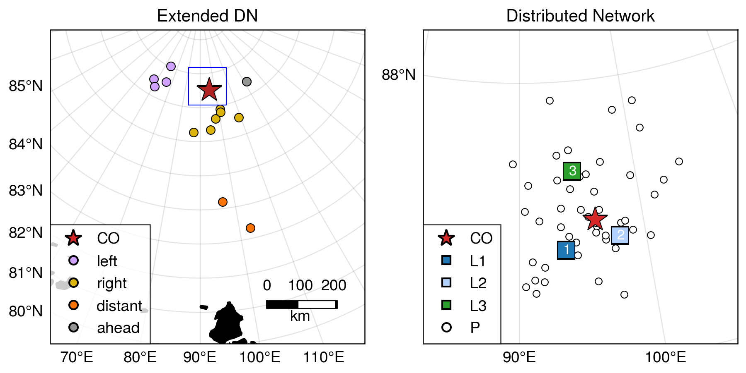

**Figure 1**. MOSAiC domain and instrument locations on 1 February 2020 at 00:00 UTC. Shown are the Central Observatory (red star labeled CO), the 3 “L-sites” with the ASFS, SIMB and AOFB (squares, right hand panel) measuring complete atmospheric, ice and upper-ocean parameters, and the GPS ice buoys (circles) measuring position. Colors of GPS buoys in left panel correspond to groups defined and highlighted in Figures 7 and 9.

2.2 ERA5 atmospheric reanalysis

We supplement the in situ atmospheric observations with data from the fifth-generation European Center for Medium-range Weather Forecasting reanalysis (ERA5; Hersbach et al., 2020). The ERA5 reanalysis performs well relative to other reanalyses in the Arctic domain (Graham, Cohen, et al., 2019; Graham, Hudson, et al., 2019). ERA5 is known to have a surface warm bias in the Arctic (Wang et al., 2019; Yu et al., 2021); here, we use ERA5 mean sea level pressure and 10-m winds, and 850 hPa temperature and humidity, and we use observational data for near surface temperatures. Rawinsonde and surface observations from the MOSAiC central observatory were assimilated by ERA5, as were surface measurements of temperature and air pressure from numerous meteorological buoys from the MOSAiC Distributed Network. As such, we consider the ERA5 fields used here to be a reasonable estimate for use in describing the structure of the storms analyzed here. ERA5 data at 0.25 degree resolution was obtained from the Copernicus Data Store (Hersbach et al., 2023b, 2023a). Prior to analysis, the data was reprojected on a regular 25 km north polar stereographic grid with central longitude 90°.

2.3 Sea ice observations

An array of drifting buoys (Bliss et al., 2023a), the MOSAiC Distributed Network (DN), track sea ice motion and deformation. Figure 1b shows DN sites on February 1st, 2020 within 60 km of the central observatory. An additional 13 buoys provide information on larger-scale ice motion (Figure 1a, colored circles). Each buoy reports positions via the Global Positioning System (GPS) with time resolution ranging from 10 minutes to 4 hours; the majority of buoys sampled at least once every hour. We only use buoys with time resolution of three hourly or less. Initial buoy processing followed Bliss et al. (2023b). Anomalous data with large random GPS errors were identified and removed by calculating the Z-score of the minimum of velocities estimated by forward and backward differences relative to a 3 day centered window. Observations were interpolated to 30-minutes with natural cubic splines. During the study period, 64 position (P) buoys operated, out of which 57 fit our criteria for use. An additional 11 sites (including the L-sites and the CO) contain multiple instruments. We selected a reference buoy from each of these sites, preferring those with higher sampling rate and data precision (Table S1). Choice of reference buoys in most cases is arbitrary, as the buoys at each site are closely situated typically reported hourly.

The trajectories of the DN sites provide information about the divergence, shear and vorticity of sea ice inside the Distributed Network. We calculate strain-rate components using a Green’s Theorem method, following Hutchings et al. (2011, errata 2018). The area over which deformation is estimated can be varied depending on sites chosen to surround the region of interest. We consider deformation on a variety of scales including: the triangle with L-sites at its vertices, a set of 5 polygons with length scales of 15-30 km covering the DN, and a polygon enclosing the full DN with length scale 57 km. Polygons used for deformation calculations are shown in Figure 9d-g.

2.4 Sea ice radar imaging

Local sea ice deformation observations were obtained from a ship radar image digitizing system. The system was connected to the 9.4 GHz X-band radar mounted at the roof of the *R/V Polarstern*. Images of sea ice backscattering were collected with 8.3 m resolution every 2.5 seconds. Due to low incidence angle and shadowing effect of sea ice ridges, maximum range of sea ice imaging was about 10 km.

2.5 Upper-ocean turbulence and current measurements

Ocean timeseries observations were made from Autonomous Ocean Flux Buoys (AOFBs; Stanton et al., 2012) adjacent to the CO Met Tower and from the three L site ice floes (Figure 1) nominally 12-25 km out from the CO. Each of these buoys supported a 4 m depth eddy-correlation turbulence sensor package providing direct heat, salt and momentum fluxes every 2 hours from 35 minute ensemble co-spectra of the 2 Hz sampled 3-component velocity, temperature and conductivity timeseries. Ocean friction velocity $u^{*}={\left({\left\langle u^{'}w^{'}\right\rangle }^{2}+{\left\langle v^{'}w^{'}\right\rangle }^{2}\right)}^{0.25}$ from these co-spectra are used to infer the upper ocean stress ($ρ_{o}u^{*}$) at 4 m. A co-located Acoustic Doppler Current Profiler (ADCP) measured current profiles from 6 m to 80 m depth sampling every at 2.5 s and every 2 m in depth, and reporting 15 minute ensembles with <1 cm s-1 noise levels. Earth-referenced absolute current profiles were calculated from the instrument-coordinate ADCP measurements by first rotating the component profiles into true north coordinates using declination-corrected flux gate compass measurements in the ADCP and flux package, and where possible, comparison with shipboard and ASFS GPS-based heading observations. The AOFB / ice floe horizontal motion was then removed using the AOFB GPS timeseries to form absolute u/v vector current profiles.

Data from the buoys were uploaded to a server at the Naval Postgraduate School (NPS) twice a day (<https://www.oc.nps.edu/~stanton/fluxbuoy/deploy/deploy.html>) providing long term unattended observations until consumed by the dynamic ice floes encountered during the MOSAiC drift. In this study, ocean measurements from the CO site adjacent to the main Met Tower are used. Water density profiles were calculated from the intermittent ships CTD and microstructure profiling program at the CO. Difficult operating conditions during this period of very high winds limited CTD sampling at the CO to as little as once per day. Seasonal mixed layer depths are estimated from the depth in each profile where there is a 0.2 Kg m-3 potential density increase from the 8 m near surface values. These sparse-in-time mixed layer depths are linearly interpolated depths and smoothed with a ½ day period filter to estimate the depth of the top of the strong halocline observed across much of the Arctic. A much more sensitive density threshold of 0.01 Kg m-3 is used as an indicator of the base of the active surface boundary layer in the analysis in section 5.

2.6 Coupled Arctic Forecast System (CAFS) modeling

CAFS is a limited-area, fully coupled, ice-ocean-atmosphere-land model adapted for forecasting on the weather-scale from the Regional Arctic System Model (RASM) (Cassano et al., 2017; Maslowski et al., 2012) and includes the following components configured for the pan-Arctic region: Weather and Research and Forecasting (WRF) atmospheric model (Skamarock & Klemp, 2008); Parallel Ocean Program (POP2) ocean model (Smith et al. 2010); Los Alamos National Laboratory (LANL) Community Ice Model (CICE5; Hunke et al., 2015); and the NCAR Community Land Model (CLM; Lawrence et al., 2019). The components are coupled using a regionalized version of the CESM flux coupler (CPL7), which includes modifications important for resolving the sea ice pack’s inertial response to transient (i.e., weather-scale) events (Roberts et al. 2014). All components are run with a 9-10 km horizontal grid spacing.

The sea ice model implements the momentum balance in Equation 1. For the ocean stress, the model uses the surface layer currents $\vec{u_{o}}$  to determine the stress between the ocean and ice, and subsequently the ice velocity $\vec{u}$. This stress, relative to the ice, is calculated with a quadratic drag law

$$\vec{τ_{o}}=c_{o}ρ_{o}\left|\vec{u_{o}}-\vec{u}\right|\left(\vec{u_{o}}-\vec{u}\right)\cos{θ}+\hat{k}×\left(\vec{u_{o}}-\vec{u}\right)\sin{θ} (3)$$

is then passed to the ocean model. Here, $θ$ is the turning angle between geostrophic and surface currents, $c_{w}$ is the ocean drag coefficient, $ρ_{w}$ is the density of seawater, and $\hat{k}$  is the vertical unit vector. The top ocean layer is assumed to be sufficiently thin compared to the typical depth of the Ekman spiral, hence $θ$ is set equal to zero. Similarly, the stress between the atmosphere and ice is calculated as

$$\vec{τ_{a}}=ρ_{a}{u^{*}}^{2}\frac{\vec{u_{a}}-\vec{u}}{|\vec{u_{a}}-\vec{u}|} (4)$$

where $u^{*}$ is the turbulent scale for velocity difference, $ρ_{a}$ is the density of air, and $\vec{u_{a}}$ is the wind at the lowest atmospheric model level. The turbulent scale $u^{*}$ is calculated as

$$u^{*}=c_{u}\max{(U_{Δmin}, }|\vec{u_{a}}-\vec{u}|) (5)$$

where $U_{Δmin}$ is set to 0.5 m/s and $c_{u}$ is calculated using stability functions following Kauffman & Large (2002) for unstable conditions and Jordan et al. (1999) for stable conditions.

3 Atmospheric structure and evolution

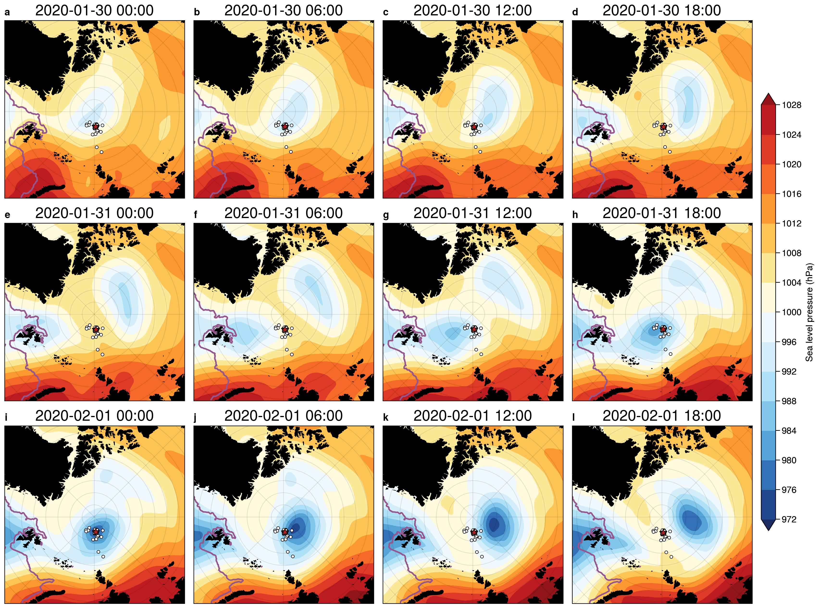3.1 Synoptic evolution

**Figure 2**. Sequence of ERA5 mean sea-level pressure (SLP) analyses at 6-hour intervals from 30 January 00:00 UTC to 1 February 18:00 UTC centered on the North Pole. The red star indicates the location of the CO, and the black dots show the buoys in the DN. The position of the ice edge from the daily NSIDC 12.5 km AMSR2 sea ice concentration, defined as the 15% sea ice concentration isoline, is indicated with a purple line.

The MOSAiC observatory was impacted by numerous cyclones during the winter of 2019-2020 (Rinke et al., 2021). Two cyclones impacted the MOSAiC domain in short succession between January 29th and February 1st, 2020 (Figure 2). The first low (L1) developed along the NE coast of Greenland at approximately 29 January 06:00 UTC, and strengthened slightly as it moved northward directly over the North Pole. Soundings at the *R/V Polarstern* suggest that a warm front/cold front couplet developed with the system as indicated in Figures 3 and 5, and that the warm sector passed over the MOSAiC domain. As this first cyclone was passing the MOSAiC domain, a second cyclone (L2) developed along the west coast of Svalbard on 30 January and strengthened along Svalbard’s north coastline as it moved northward. While the first cyclone only deepened by about 7 hPa along its track, the second cyclone deepened by nearly 20 hPa, becoming one of the deepest cyclones to pass over the MOSAiC domain during the year, resulting in large surface pressure gradients and hence strong winds. The observed SLP minimum in the MOSAiC domain (974 hPa) was 4 hPa lower than the minimum central pressure in the analyzed fields, indicating that the observed cyclone was slightly stronger than that represented in these analyzed fields. This second cyclone center passed much closer to the MOSAiC domain than the first one. Soundings from the *R/V Polarstern* also showed that a warm front/cold front couplet developed with this system, and that both the warm front and cold front passed over the MOSAiC observatory.

Figure 2 suggests that L2 is more axisymmetric (circular) than the L1. While the evolution and tracks of the cyclones in ERA-5 reanalyses are nearly identical to those in the Deutsche Wetterdienst analyses (not shown), the SLP fields calculated from ERA-5 more clearly show the difference in symmetry between the two cyclones. While the second cyclone is quasi-symmetric initially and becomes even more symmetric as it strengthens, the first cyclone starts out more elongated and becomes even more so with time. The first cyclone appears eventually to be absorbed into the second cyclone. We hypothesize that the extent of this axisymmetric structure has importance for the mesoscale low-level jet (LLJ) feature to be discussed in the next section.

3.2 Key mesoscale structures

Figure 3 shows an atmospheric frontal analysis based on the 6-hourly ERA-5 mean sea-level pressure and 925 hPa equivalent potential temperature ($θ_{e}$) and winds. In this and following figures, references to cardinal directions are relative to the CO. The maps are oriented so that north from the CO is in the positive *y* direction and east is in the positive *x* direction; note that the North Pole is 267 km north of the CO, so the direction of true north will vary substantially throughout the figure. The storm has clear spatial structure, with a cold sector to the left of the storm track and a warm sector to the right.The surface warm front passes over the CO (red star) on 31 January between 14 UTC and 16 UTC, while the cold front passes over the CO on 1 February near 00 UTC (aloft) and near 02 UTC (surface). The surface low passes very close to the CO but just to its west and north, such that the CO is initially in the the warm sector. The strong low-level wind speeds of the low-level jet (LLJ) initially occur in the warm sector between the warm front and the cold front aloft. By 1 February 00 UTC (Figure 3b), the LLJ (indicated here by the 16 m/s isotach) encircles the surface low and remains as a nearly axisymmetric annulus through the rest of the time period as the system occludes with bands of warm and cold air wrapping around the low center. While this spatial image is in excellent agreement with the observational analyses to be shown later in this section, and shown in other studies (e.g., López-García et al., 2022), this is expected as the ERA5 reanalysis assimilated the 6-hourly rawinsondes and surface data from the *R/V Polarstern,* as well as surface meteorology (temperature, pressure) from a subset of the DN buoys.

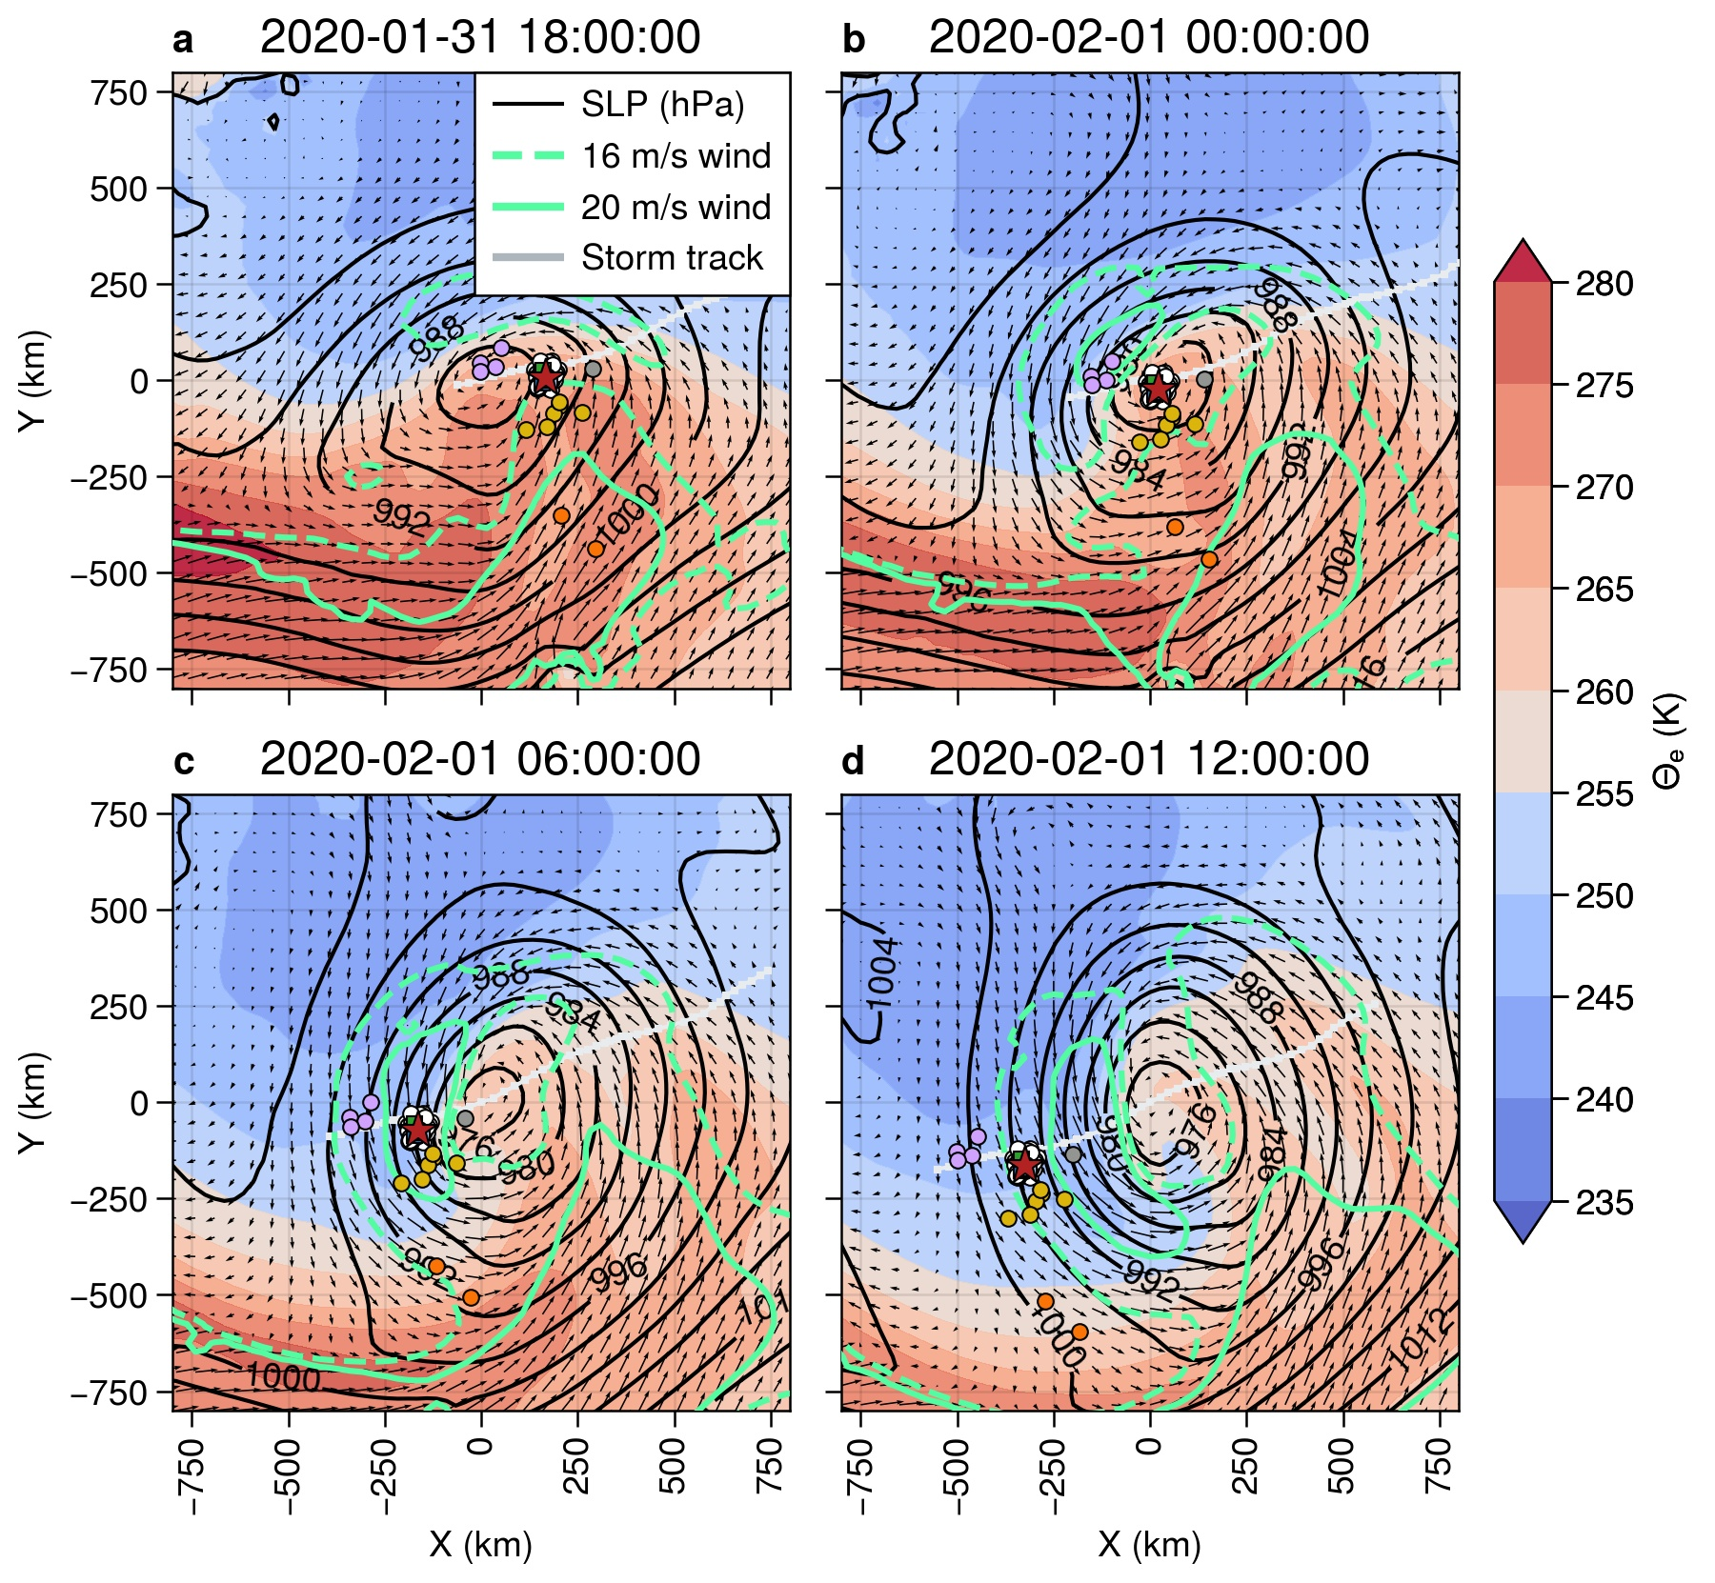

**Figure 3**. ERA5 reanalyses centered on the pressure minimum. Shown are mean sea-level pressure (hPa; black isopleths), 925 hPa equivalent potential temperature (K; colors), 10 m wind vectors, select 925 hPa isotachs (16 & 20 m/s; green). The heavy red (blue) lines show the positions of the warm (cold) fronts. The dashed fronts are thermal features aloft, while the solid ones are surface-based features. The light gray line shows the track of the low center within the domain, while the colored circles show the positions of observational sites within the DN. Colors for DN and Extended DN sites are as in Figure 1.

Utilizing the near-surface observations at the three ASFS sites and at the CO, rough observational surface analyses are possible on the ~50 km scale of the DN. Figure 4 shows isotherm analyses centered on the CO between 31 January 14:05 UTC, just prior to the passage of the surface warm front, and 1 February 06:41 UTC, nearly 5 hours after the passage of the surface cold front. These are overlaid on a low-elevation radar-reflectivity PPI scan from the scanning Ka-band radar to provide some indication of the spatial distribution and structure of the clouds and precipitation.

Moderate (5-10 m/s) southeasterly surface winds were present throughout the domain as the air temperatures warmed with the approaching surface warm front, which passed over the CO just before 31 January 16:00 UTC (Figure 4b). Within the warm sector, temperatures gradually warmed to -12 °C and winds were initially moderate from the SSW but decreased in magnitude as the CO neared the low-pressure center, particularly after the cold-front aloft passed overhead. The more cellular nature of the clouds and precipitation after the cold front aloft passed can be seen in comparing Figure 4c and 4d. The trailing surface cold front entered the DN from the NW, marked by a sudden wind shift to the N and a trailing, very strong temperature gradient (Figure 4e-g). Air temperatures dropped to between -27 °C and -30 °C. The cold front took about 1.5 h to traverse the DN. The northerly winds increased throughout this frontal zone, reaching near-surface (4 – 6 m height) speeds of 12-15 m/s as the LLJ behind the front passed overhead (Figure 4 panels h-i). The strong winds, combined with the strong cold-air advection, leads to strong mixing near the surface, producing what appears to be horizontal roll vortices in the atmospheric boundary layer (suggested by the linear, along-wind, cloud features). Horizontal roll vortices are an effective mechanism for vertical mixing in the atmospheric boundary layer (Etling & Brown, 1993; LeMone, 1973).

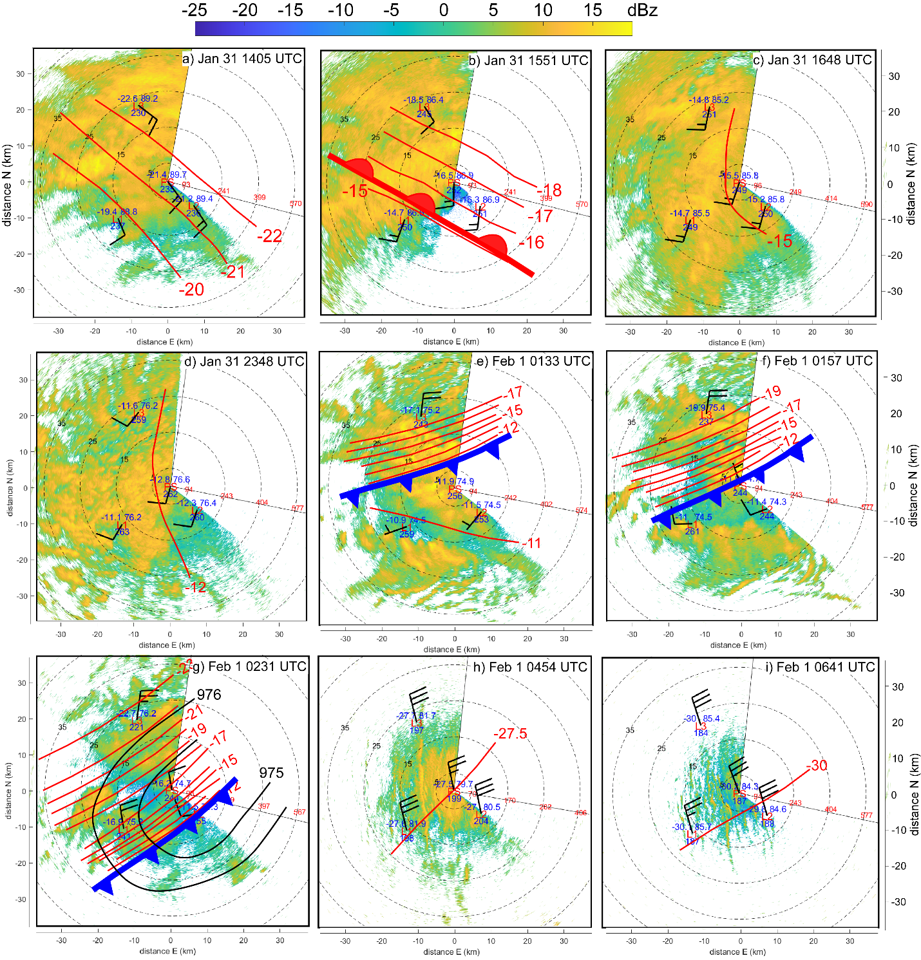

*Figure 4: Near-surface meteorological observations (Ta, MSLP, LWd, and wind barbs) and Ta isotherm analysis (deg C; red lines) from the 3 remote ASFS L-sites and 6-m height at Met City (PS) during the warm-frontal (heavy red, lobed line) passage on Jan 31 (a-b), cold frontal (heavy blue toothed line) passage on Feb 1 (e-g), and in the post-cold-frontal sector (h-i). The data also allows an isobar analysis (black isopleths) for g). Times are shown at upper right in each panel. The background shows the low-elevation scanning Ka-band radar reflectivity (color, dBz). Range rings show distance in kilometers (black) and radar-beam height above local surface (red, m). The thin black radii bracket the region not scanned by the radar. North is upwards for each panel. The manual isotherm analysis uses a 1*°*C interval. Panels with only one isotherm represent times when the sptial temperature difference between sites is less than 1*°*C.*

The time-height sections of serial rawinsondes and near-surface time series of various parameters (Figure 5) confirm the features passing over the MOSAiC domain discussed above. The passage of the first low (L1) and its associated narrow warm-sector are clearly seen, with the brief but distinct warm air peak in the warm sector, and the cooling and veering of the surface wind with the passage of the cold front. A LLJ is present at approximately 250 m above the surface near the time of the warm-frontal passage and extending into the warm sector ahead of the cold front. The second cyclone (L2) is deeper with a broader warm sector over the CO. The air only warms slightly in the warm sector between the warm front and the cold front, but the thermal wind effect of this thermal gradient, with the warmest air closest to the cold front, is the likely cause for the observed LLJ within the warm sector at 250-300 m height. The rawinsondes show the warm-sector LLJ to peak at ~15 m/s, with the associated near-surface wind measured within the MOSAiC domain to be 7-8 m/s (see also Figure 4c). The core of the warm-sector LLJ is just above the top of the surface mixed layer (SML), which is slightly deeper underneath the LLJ.

The passage of the cold front with the second cyclone near 02 UTC on 1 February marks the time of the lowest observed central pressure (974 hPa), a very sharp drop in surface temperature (-11°C to -38°C in only 12 h), a minimum in surface winds, and a rapid change in surface wind direction (see also Figure 4e-g). A second LLJ is observed at ~350-400 m height just behind the cold front with a core speed of 21-22 m/s, with again a deeper SML as indicated by the constant $θ_{v}$ with height. Just after the cold-frontal passage, the near-surface wind speed increases with the arrival of the LLJ above, reaching speeds of 14-16 m/s across the four observational sites between 04 and 05 UTC on 1 February (see also Figure 4h-i). The timing differences in the wind direction shifts and wind speed increases (Figure 5d-e) (and temperature decreases-not shown) between sites represent the progression of the cold front across the DN from the northwest. Stability differences in the sub-jet layers may cause the higher surface wind speed relative to its core strength for this second post-cold-frontal LLJ when compared to the warm-sector LLJ. A peak in the observed covariance surface stress at Met City (Figure 5f) occurs just after the cold frontal passage, and is coincident with the deepening of the SML just below the LLJ (Figure 5a) and the appearance of the likely horizontal roll vortices (Figure 4i). It is unclear whether enhanced turbulence caused by the LLJ or the apparent roll vortices have deepened the SML, or if the deeper SML has eroded the lowest portion of the strong winds thereby producing a LLJ just above the SML. All of these features indicate significant, efficient, vertical momentum transport at this time.

The presence of the LLJ behind the cold front is likely due to the LLJ being quasi-axisymmetric around this second low. That is, it is a “wrap-around” LLJ that is likely an extension of the LLJ observed in the warm sector as this warm air wraps around the strong but compact cyclone center, as seen in Figure 3. Note that there is not much of the warm air remaining with this wrap-around LLJ, and that it is at a slightly higher altitude, consistent with some lifting as the LLJ has wrapped itself around the cyclone center. The 6-h soundings do suggest a thermal wind contribution over a ~100 m deep layer at the core of this second LLJ; it is beyond the scope of this paper to examine whether this brief reversal in horizontal temperature gradient is sufficient to fully support this LLJ structure. We infer that the presence of two LLJs in fairly rapid succession, or alternatively, a wrap-around LLJ within a rapidly moving storm system, produces strong, rapid surface wind speed and wind direction changes as the cyclone translates across the MOSAiC domain, and is key for forcing the significant ice motion, ice deformation and upper-ocean current changes observed during the passage of this second cyclone. This double LLJ (wrap-around LLJ) was observed in other MOSAiC cyclones with significant ice deformation.

Low-level atmospheric divergence is one way to quantify these wind transitions, and significant atmospheric convergence is observed with the passage of the warm and cold fronts of low L2, with the strongest convergence (~30 x 10-5 s-1) occurring with the cold-frontal passage (Fig. 5g). Ice convergence and shearing show significant peaks in association with this atmospheric convergence near the cold front. There is no appreciable ice divergence/ convergence with the warm frontal passage, though there is significant shearing of the ice. Note that other wind transition events for which wind speeds are appreciable also show some atmospheric divergence/convergence and some ice deformation (e.g., near 08 UTC on 3 February, also associated with a LLJ). Nevertheless, ice deformation events can have multiple local and nonlocal causes, and therefore often are not associated with atmospheric divergence.

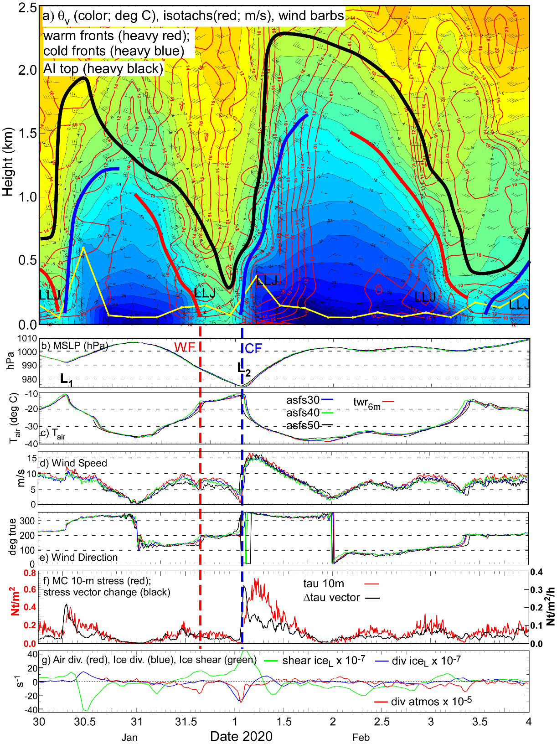

*Figure 5: a) Time-height section of virtual potential temperature (v, colors), isotachs (red), and select wind barbs from serial rawinsondes at the* R/V Polarstern*. Heavy (red, blue, black) lines mark warm and cold fronts and the top of the Arctic inversion (base of the free troposphere), respectively. The thin yellow line marks the top of the surface mixed-layer. Low-level jets (LLJ) are also marked. The 6-hourly rawinsonde times are shown at the bottom of the panel (red*). Lower 6 panels: Time-series from the Met City tower and the ASFG of b) MSLP; c) Ta; d) 10-m and 4-m wind speed; e) 10-m and 4-m wind direction; f) 10-m atmospheric stress (red), stress vector change (black) at MC; and g) 4-m atmospheric divergence (red), ice divergence (blue), and ice shear (green). The vertical dashed lines show the times when the warm (red) and cold (blue) fronts with the second cyclone pass over.*



4 Sea ice dynamics

Sea ice motion during the passage of the storm is broadly coherent with time-varying wind forcing. We examine the sea ice response during the second cyclone first in terms of the relationship with the local wind forcing, then examine the differential motion of the ice pack.

4.1 Atmosphere-ice interaction

Drift trajectories of the three L-sites and the CO (Figure 6a-d) generally illustrate the expected right hand turning rule first noted by Nansen (1902); that is, that the ice moves ~30° to the right of the wind. At all four sites, the ice drift arcs to the right and slows as the 29 January cyclone moves away from the MOSAiC site and the winds veer from SW to NW. At MSLP maximum between the two depressions, the wind direction abruptly reverses at 23 UTC on 30 January at all sites, marked by the red letter A. As the sea level pressure decreases and the second cyclone approaches the CO, the winds become southeasterly and the ice drifts northward until slowing to a halt and again reversing direction near the time of the surface cold frontal passage. The cusp in the trajectory marking the reversal is indicated by the letter B. Notably, this reversal preceeds a rapid acceleration, and occurs at different times at each site: first at 22:30 UTC on 31 January at L3, next at 0 UTC on 1 February at sites L1 and at the CO, and last at 0:30 UTC on 1 February at site L2. This is ~2 h before the cold front, which marks the leading edge of the wind direction shift, passes over each respective site (see Fig. 4e-g). Hence, the direction change of the ice motion occurs ~2 h before the change in the local wind direction. The difference in ice-motion directions before and after the cusp varies spatially as well, indicating that deformation of the ice between the sites has taken place.

In the lower two panels of Figure 6, we see that the drift speed ratio $α$ (the ratio between the floe drift speed and the local wind speed) and net turning angle $θ$ (the difference between the local wind direction and the floe drift direction) vary significantly over time. These parameters are empirical measures of the relationship between the ice drift and the winds. In steady state free drift (i.e., in the absence of internal ice stresses), the turning angle is a function of the boundary layer structure and the ice surface roughness, and the drift speed ratio is the Nansen number, a function of the air-ice and ice-ocean drag coefficients and the densities of each medium. At MOSAiC, we can calculate these directly from the three ASFS sites and Met City using the measured winds and the measured motion of the local ice floe on which these sensors are located. For the January 30-February 4 period shown in Figure 6e-f, average values of $α$ and $θ$ are 0.021 and 35, respectively, consistent with previous studies (Leppäranta, 2007; Schweiger & Zhang, 2015; Womack et al., 2022). However, significant temporal variability exists in both parameters, though their spatial variability is much less. We see an increase in drift speed ratio after 02 UTC 1 February, which can indicate that a larger fraction of atmospheric momentum is being translated into ice motion rather than adding to the internal ice stresses. In addition, we see that the drift speed ratio following the second cyclone passage (after 12 UTC Feb 1) oscillates near the inertial frequency (~12 hours), suggesting the possibility of inertial oscillations following the storm.

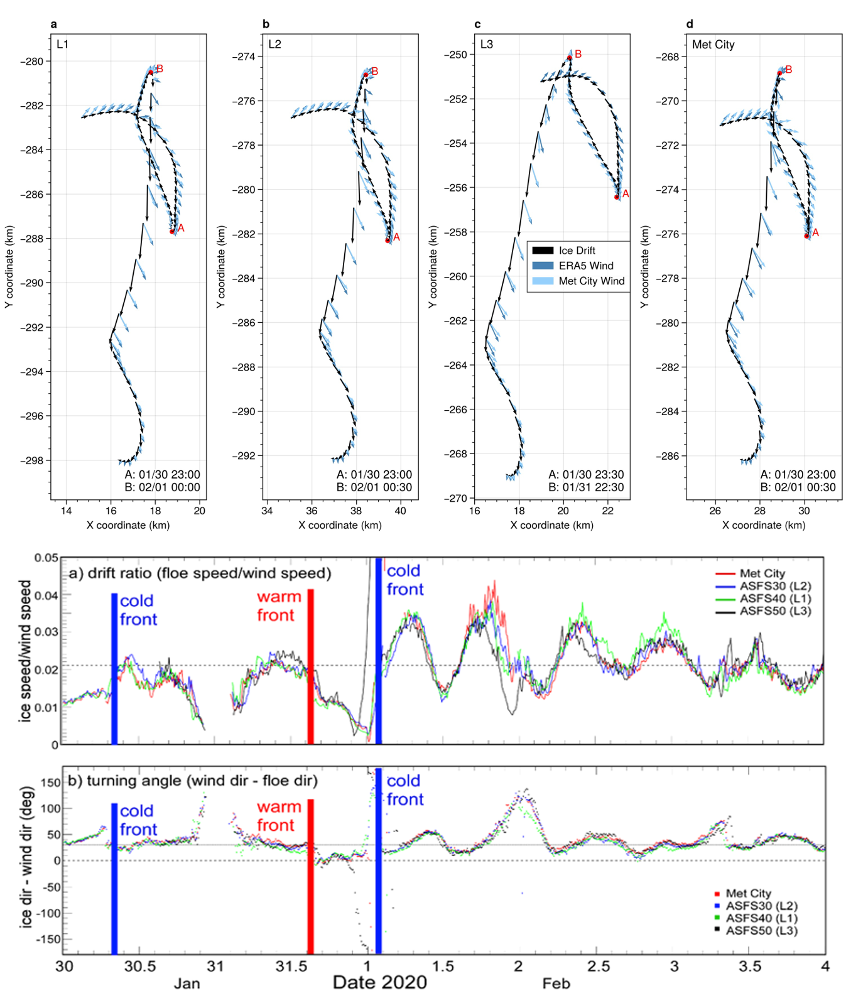

Figure 6. Top a-d: Locations of sites L1, L2, L3, and Met City at hourly resolution from 30 January 00:00 UTC to 02 February 00:00 UTC. Black arrows indicate the ice drift vectors, light blue the observed wind vector, and dark blue the estimated wind vectors from the ERA5 reanalysis. Arrow length is proportional to velocity. Bottom: (a) Drift speed ratio (ice speed divided by wind speed) and (b) empirical turning angle (difference between wind direction and ice drift direction) at sites L1, L2, L3, and Met City.

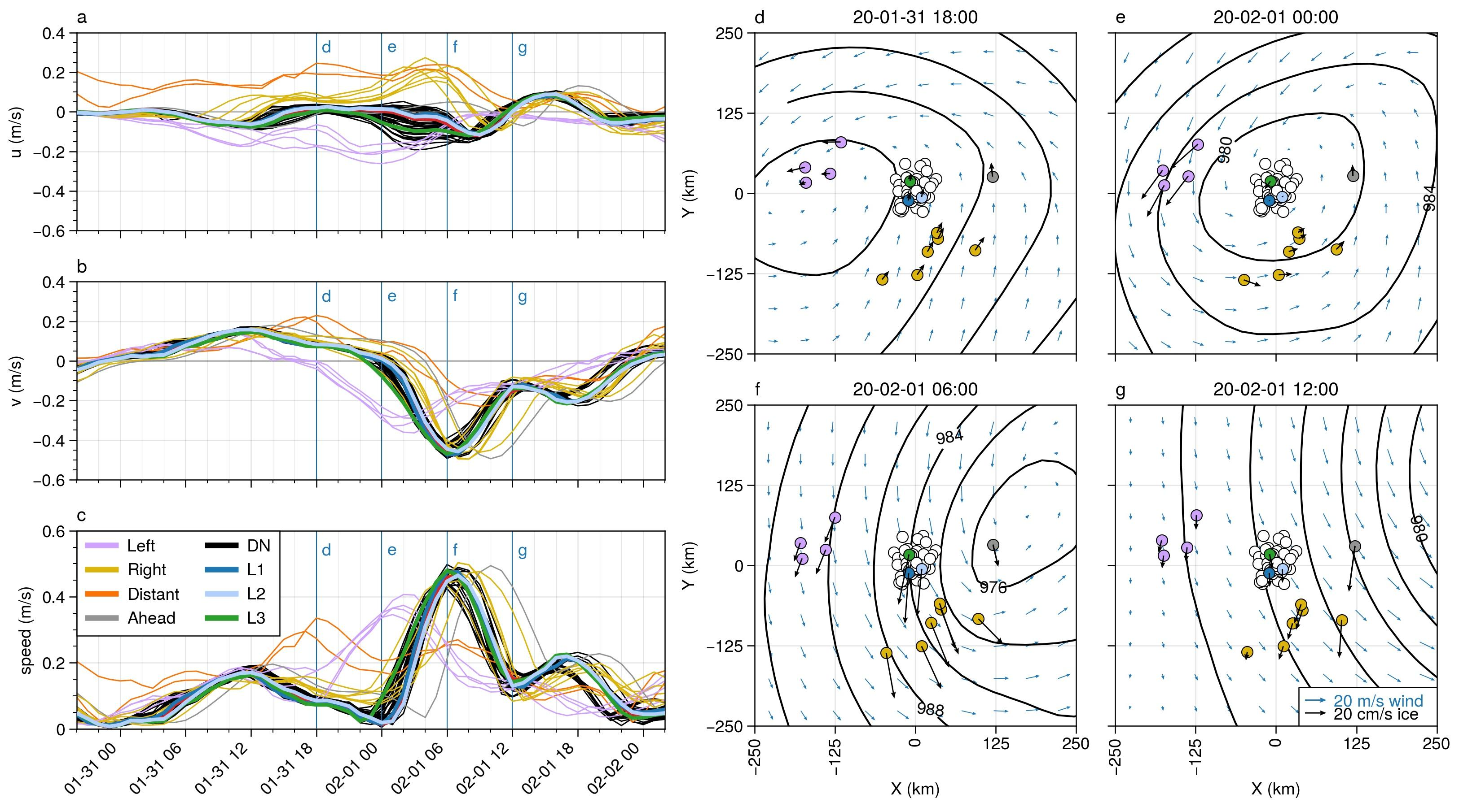

**Figure 7**. Left: Buoy velocity components (a, b) and magnitude (c) for the period from 30 January 20:00 UTC to 2 February 02:00 UTC. The top and middle panels show the u and v velocity components relative to the north polar stereographic projection, thus corresponding to the x and y axis, respectively, in the panels on the right. For the period shown here, the positive y direction is approximately northward. Right: Snapshots of buoy motion (thick black arrows) superimposed on the ERA5 sea level pressure isobars (black contours, 4 hPa spacing) and near-surface (10 m) wind fields (blue arrows) at times corresponding to vertical lines in the velocity time series to the left. The lines corresponding to the “distant” (orange) buoys in a-c are south of the domain shown in d-g but are seen in Fig. 3.

Considering next the trajectories and drift speeds across the full buoy dataset, we find a clear correspondence between the position of the buoys relative to the storm track and the time varying drift velocity (Figure 7a-c). Groups are colored and named relative to the propagation direction of the storm. Within-group velocity variance is small compared to the cross-array variance, and we note that buoys on opposite sides of the storm track move in opposite directions in the *x* direction, consistent with the rotation of the cyclone wind field. The clearest sign of the storm impact on the ice velocity is through the effect of the LLJ as it develops and moves across the MOSAiC array. The high wind speeds associated with the LLJ in the warm sector (Figures 3 and 5) accelerate the two distant buoys (orange in Fig. 3a) first in Fig. 7c, which reach maximum velocities of 29 and 33 cm/s on 31 January at 17 and 18 UTC, respectively. The remaining buoys show a moderate increase of speed on 31 January from 00 UTC to 12 UTC as the central pressure low and associated LLJ annulus approaches. The ice velocities of most of these close-in buoys decrease until 00 UTC Feb 1 as the weaker winds at the center of the annulus (at the low center) passes over them. The only exceptions are the purple (“left”) buoys that are forced by the wrap-around portion of the LLJ annulus on the left side of the storm track. After the low center and the surfce cold front pass through, the main cluster of DN buoys are affected by the strongest portions of the wrap-around LLJ (cold-sector LLJ), accelerating them to speeds of nearly 0.5 m/s.

During the 30 January storm, we see a similar pattern of differential motion across the extended DN, though to a lesser extent (Figure S1); maximum drift speeds are between 10-20 cm/s. We note that no cold-sector LLJ is visible in the sounding data (Figure 5a), and that the sea level pressure fields from ERA5 (Figure 2) indicate that the pressure low was weaker than for L2, did not pass directly over the MOSAiC DN, and reached maximum depth after the storm had moved past the MOSAiC array. Therefore, it is likely that if a cold-sector LLJ developed, it developed after the storm had left the MOSAiC site or it was closer to the low center and didn’t pass over the MOSAiC DN buoys.

The propagation of the LLJ behind the cold front during the February 1 cyclone is evident through the timing of maximum drift speeds. The left group remains moving at elevated velocity and stays to the left of the storm in the cold sector. It is the first group to be accelerated by the cold sector LLJ. These buoys accelerate to an average speed of 37 cm/s, reaching maximum speeds between 01 and 02 UTC on 1 February. The DN buoys and the right group reach their maximum speeds at approximately the same time (Figure 7c, f) yet due to the difference in distances in the radial direction the direction of motion is different. The buoys in the DN come nearly to a full stop before reversing direction and being accelerated by the cold-sector LLJ, and there is a larger spread in velocity between the DN buoys during this time. Maximum speeds of 42-49 cm/s are reached between 5 and 8 UTC on 1 February, corresponding to the time of the post-cold frontal LLJ. The passage of the LLJ, as indicated by the rise and fall of sea ice velocity, occurs within approximately 12 hours. For a storm propagating at close to 25 km/hour and using half the trough-to-trough time, this suggests that the atmospheric feature and its ice response is on the order of 150 km wide. Thus, the strongest impact of the storm on the ice velocity is occurring at time scales only adequately captured by satellites with return frequencies of 4X daily or more, and by models with about 25 km resolution or less.

The 48-hour drift trajectories of the DN and Extended DN show the imprint of spatially-varying winds across the storm system (Figure 8). The furthest buoys from the storm track show the gentlest arcs, with clockwise propagation to the right of the storm and counterclockwise propagation to the left, while the trajectories of buoys in the DN display cusps indicating a rapid change in direction. We calculate the timing of the cusp by finding the time of the absolute drift speed minimum for the 24H period centered at 1 February 00:00 UTC. As shown in Figure 8b, there is a NW-SE gradient in cusp timing spanning a 3-hour period, with the cusp occurring earliest to the NW and latest to the SE. The timing of propagation is consistent with ~25 km/h propagation of the cyclone, yet we can see in the spatial variability of the cusp timing that the ice motion is not purely a response to the NW-SE movement of the cold front and the wind transition (see Fig. 4)—the activation of fractures and the jostling and redistribution of ice floes results in additional variability in the timing and character of ice motion. Of particular note is the fact that site L3 (blue box in the upper part of Figure 8b) changes direction at the same time as the buoys to the north and west, and moves two hours before site L1 (white box in the lower middle of Figure 8b). Note that the timing for Fig. 8b is centered on 00 UTC Feb1, which means that the moving ice transition (cusps) occur approximately 2 hours before the cold front produces wind direction transitions at each buoy (see Fig. 4). Hence, the ice motion transition precedes the wind transitions throughout the DN. One possible explanation is that internal ice pressure waves move ahead of the atmospheric momentum forcing.

4.2 Sea ice deformation

The passage of the storm induces significant deformation of the sea ice. We measure this deformation by monitoring the changes in polygons formed by subsets of the buoy array (Figure 9d). The length scales of the polygons (square root of the average polygon area) are 28, 33, 28, 30, and 15 km for DN sub-arrays 1-5 respectively, 18 km for the L-site triangle, and 57 km for the “DN Full” array. Strain rate calculations from polygons are based on a Green’s theorem representation of velocity gradients, and as such are estimates of area-averaged strain rate (Hutchings et al., 2011, errata 2018). Hence, the DN Full array is an estimate of deformation across the array, while the smaller polygons give an indication of the variability within the array.

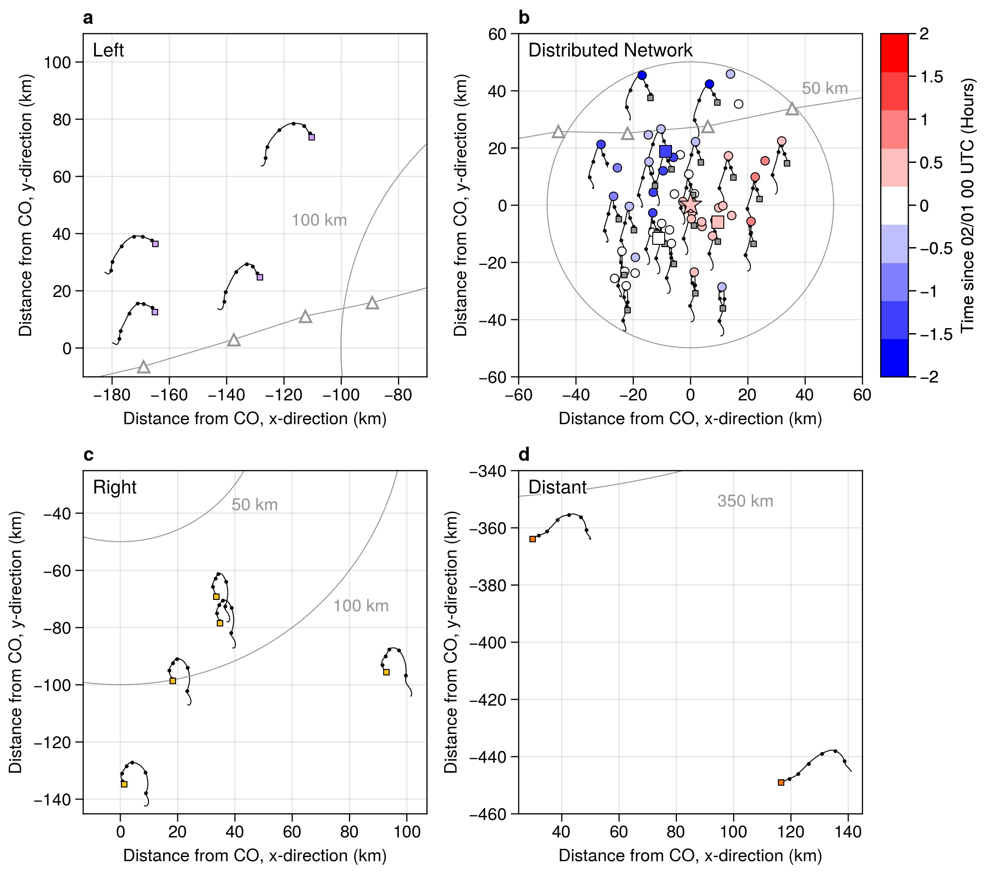

**Figure 8**. Buoy trajectories from 31 January 00:00 UTC to 2 February 00:00 UTC. Small squares indicate the beginning of the time series. Black lines show the 30-min resolution drift tracks, and black circles show the position every 6 hours. Distance from the CO is indicated with the axis units and radii at 50 km, 100 km, and 400 km. In panel b, the time of the drift speed minimum relative to 1 February 00:00 UTC is indicated with color. Trajectories of a subset of DN buoys are shown for clarity. L-sites are marked with large squares, while the CO is marked by a star. In panels a and b, the position of the sea level pressure low from the ERA5 reanalysis is marked at hourly intervals with white and gray triangles.

Initially divergence is small, with isolated polygons showing spikes; most deformation is due to shear strain (Figure 9a-b). At the time of atmospheric convergence with the warm-frontal passage near 15 UTC January 31 (see Figure 5g), very weak or no ice divergence is seen. From 18-21 UTC on January 31 the sea ice is nearly quiescent. Shear strain rate increases at 21 UTC followed shortly by an increase in the magnitude of divergence. We note high variability across the array for both divergence and shear strain rate. Most of the DN polygons follow the same pattern as the full DN: positive divergence as the center of the low passes over the DN, reaching maximum values at or just before the drift speed peak occurs at ~07 UTC Feb 1 (compare Figure 7c). The divergence of the L-site polygon is a notable exception, with strong convergence at ~02 UTC near the time of the atmospheric frontal passage and peak in atmospheric convergence (see Fig 5g) . Maximum shear strain rate has local maxima at about this same time as the ice accelerates before the drift speed maximum and during the deceleration afterward; an additional local maximum in shear strain rate occurs 12 hours later. Vorticity shifts from anticyclonic to cyclonic near 09 UTC Jan 31 as the ridge between storms passes and the second cyclone approaches. The vorticity signal is broadly coherent throughout, with a clear peak in positive vorticity at 2-3 UTC on 1 February and strongly negative vorticity between 9-11 UTC on 1 February. This coherent multi-scale positive ice-vorticity signal should be expected from the presence of the narrow axisymmetric atmospheric LLJ surrounding the cyclone. The positive vorticity signal as the storm approaches is damped because the LLJs developing in the warm and cold sectors of the storm had not yet joined; the winds ahead of the low center were weaker than the winds behind it (see Figs. 3 and 5).

Interestingly, the polygon formed by the L-sites (the L-site triangle) shows convergence as the pressure low passes through the DN, while the remaining DN polygons indicate divergence (opening). Considering the wind field shown in Figure 7d-g and the tendency of ice to move to the right of the wind, we expect opening while the low is centered over the DN. In pack ice, individual floe motion is limited by interaction with neighboring floes, leading to “multifloe” (~2-10 km) and “aggregate” (10-75 km) motions in the hierarchy proposed by McNutt & Overland (2003). We see this in the velocity anomaly fields of Figure 9. In Figure 9d, the sea ice is mostly moving coherently in the DN, hence there is little deformation in the L-triangle. In Figure 9e (00 UTC Feb 1), we see that a shear zone activates that neatly bisects the DN. The timing and the direction of motion is consistent with increased atmospheric stress from the approaching cold front (see Figure 4e). The buoy velocity anomalies show that a region of at least 20 by 60 km is moving approximately coherently within the DN. Station L3 (northern L site with green circle in Figure 9d-g) is on the opposite side of the shear zone from the other two L sites (blue and light blue circles). The result of this activating shear zone is a strong average shear strain rate and convergence of the ice in the L-triangle. Note the correspondence between the atmospheric convergence and ice convergence at this time in Figure 5g. Likewise, polygon DN 4 (dotted lines in Figure 9) overlaps the shear zone and has similar large maximum shear strain rates; since this polygon is a quadrilateral and slightly larger than the L-triangle, it is less sensitive to the area change, and shows only slight convergence. As the wind direction changes, the geometry of the interlocked floes results in different regions moving as aggregates.

In comparison, the storm on 30 January induced a similar but weaker response (Figure S2). As with the 1 February storm, the largest deformation response occurs at close to the time of the passage of the front. For this weaker cyclone, the full DN shows no significant divergence, while still showing a local maximum in maximum shear strain rate, and shows the same vorticity pattern with weak cyclonic vorticity during the approach of the front and anticyclonic vorticity thereafter. Deformation is localized. Here, the L-site triangle shows positive divergence while polygon DN 4 straddles a north-south oriented shear zone near L2 and shows convergence. We note in Figure S2d that there is evidence that the shear zone near L3 activated (weakly) during this storm; it is possible that the ice in the shear zone was weakened by the first storm enabling a stronger deformation response during the second storm.

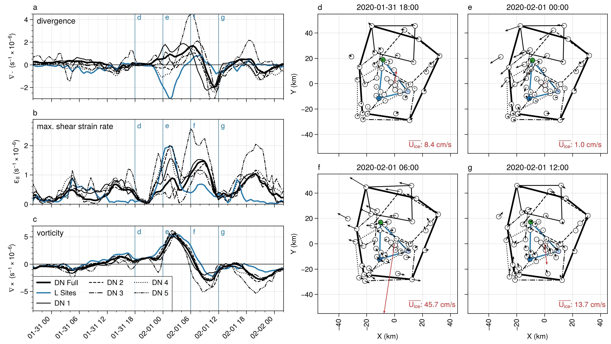

**Figure 9**. Strain rate components (a-c) and velocity anomalies (d-g) of the Distributed Network for the February 1 cyclone. Polygons used for the deformation calculations are shown in panels d-g. The polygons were selected manually; note that the buoy in the upper left was not included in the “DN Full” array due to periods of missing data. Velocity anomalies in panels d-g were computed relative to the ensemble average velocity, which is shown as the red arrow at the center of each panel.

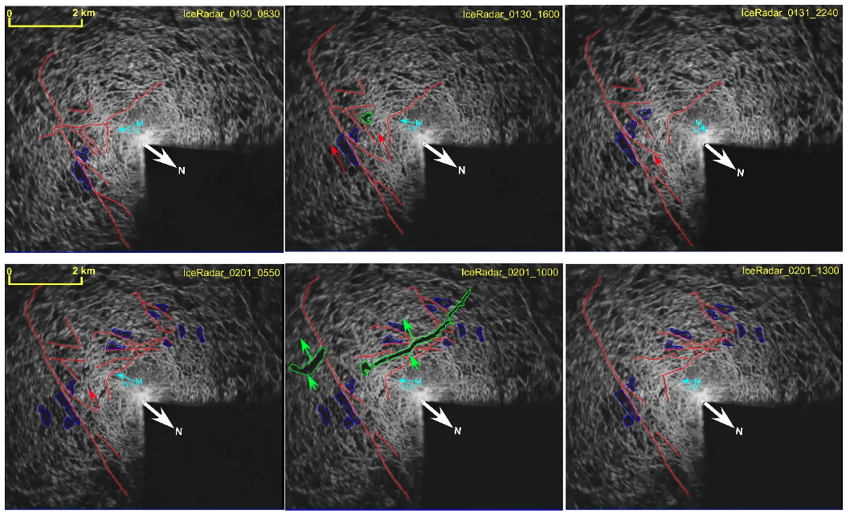

**Figure 10**. Backscatter from the ice radar on board the R/V Polarstern showing the establishment of an ice shear zone to the east and south of the ship. Images are at (a) 0830 UTC Jan30, b) 1600 UTC Jan 30, and c) 2240 UTC Jan 31 d) 0550 UTC, e) 1000 UTC, and f) 1300 UTC. The red lines (blue polygons) mark areas of enhanced or suppressed backscatter that are present in one image to the next. The green polygon shows regions of suppressed backscatter that appeared since the previous frame, the red arrows show the relative motion for that portion of the ice. The cyan number and arrow show the wind speed and direction at 10-m height from the Met City tower (M). The dark sector is blocked from the radar by the ship superstructure.

The ice radar images provide details of the ice deformation near the MOSAiC Central Observatory (CO). Figure 10 depicts sea ice roughness features around the CO. Dark areas in radar images are interpreted as undeformed level ice or leads. Bright backscattering arises from ridges and edges of leads. Changes in images are directly related to relative displacement of sea ice objects from the *R/V Polarstern* or formation of new leads and ridges. The first pair of images illustrates the shearing that occurred between 08:30 and 16:00 UTC on 30 January, establishing a shear zone near the CO that then activated again between 22:00 UTC on 31 January and 00:00 UTC on 1 February. This latter time period of shearing motion corresponds to the peak in shear near 23 UTC on 31 January in Figure 9b. The red arrows in Figure 10b mark the section of ice that moves upward and to the left on the left side of the *Polarstern*, actually opening a small lead area (green). The relative movement can be seen by comparing the relative positions of the highlighted common backscatter regions in each panel. This region of ice again moves upward a little in Figure 10c. The ice divergence maximum occurring near 06 UTC on 1 February in Figure 9a is also apparent in the ice radar data in Figure 10 between 05:50 UTC and 10:00 UTC on 1 February, two leads 100-200 m across and 1-4 km long open up about 2 km downwind of the *R/V Polarstern* (green areas in Figure 10e), indicating ice divergence. Note that this time period also corresponds to the period of large atmospheric stress (Figure 5f) and the atmospheric horizontal roll vortices (Figure 4h-i). However, over the next 3 hours, these leads close, indicating ice convergence. Figure 9a shows ice convergence occurring between 09:00 UTC and 13:00 UTC on 1 February, in excellent agreement with the ice radar observations.

5 Upper ocean response to sea ice motion

Comparisons between the wind, ice and earth-reference current speeds at 5, 20 and 60 m depths (Figure 11a) summarize the transfer of momentum from the atmosphere, to the ice, and then to the ocean. This timeseries is dominated by distinct wind events on 30 and 31 January, and the strong transient event early on 1 February (Figure 11a; see also Figure 5). Each wind event accelerates the ice, which in turn accelerates the ocean layer below the ice as the turbulent ocean Ekman boundary layer forms. This can most clearly be seen in the 1 February event with wind magnitude dropping to near zero, within the annulus of the atmospheric LLJ, followed by an increase to 16 ms-1 in the following few hours. A local maximum ice velocity of 0.5 ms-1 lags the wind speed peak by 3 hours, while a 0.27 ms-1 current speed maximum at 8m depth lags the ice speed maximum by ~1 hour compared to ~2 hours at 20m depth. These temporal lags are a result of the inertia of first the surface wind stress accelerating the ice, and then the depth-dependent acceleration of the upper ocean as the ice-ocean turbulent boundary layer forms in response to changes in direction and magnitude of the ice motion.

Rapid changes in ice speed and direction during this event also force significant levels of circular inertial motion in the coupled ice-ocean system. This can be seen in the dampened oscillatory current components in the north-south and east-west velocity timeseries in Figures 12c and 12d, starting near 1 February at 06 UTC on with the inertial ringing decaying over the following two days. The observed ocean currents represent a superposition of inertial ringing and the evolving boundary layer currents forced by the 02 UTC wind event on 1 February and subsequent smaller wind maxima at 12 UTC on 2 February and 00 UTC on 3 February. The inertial ringing is a resonant response to the combination of sharp transient lateral accelerations of the ice/upper ocean coupled with the orthogonal Coriolis acceleration. They are widely observed in the Arctic, with higher magnitudes seen in high open water fraction conditions where ice mobility is enhanced (for example, Brenner et al., 2023). For this event, the 5 m depth east-west currents track the ice motion very closely (Figure 11a) with a small phase lag and reduced current component magnitude at 20 m, while the north-south component shows an inertial response from the ice down to at least 20 m but with a larger mean boundary layer current superimposed during 1 February. As expected, there is little direct coupling of this inertial motion below the seasonal ~40 m deep mixed layer at the 60 m depth time series, as the strong density jump at the base of the seasonal mixed layer greatly reduces mixing and hence momentum transfer to greater depths.

Comparison between atmospheric surface stress and 4 m ocean stress during this period (Figure 12e) shows a deficit on the ocean side of the ice. There are two primary reasons for this difference, which are explored in detail in **Stanton et al 2023 in prep**. The first is the ability of the ice pack to remove surface-imposed momentum through a combination of internal ice stresses and ice deformation. The second is the important role of form drag in the MOSAiC ice pack. The momentum transferred by ice keels and floe edge features is not captured by the friction velocity u*. It arises from upstream, small scale roughness features across the ensemble of ice floes and generates the turbulent ocean boundary layer. The lag between the peaks of atmospheric stress and ocean stress, most clearly seen in the strong 1 February event, arises from the inertial lag of the ice pack to surface wind stress.

The vertical structure of upper currents in response to this wind event (Figure 12) illustrates the fairly complex interaction of the ice/ocean boundary layer with weakly stratified mesoscale ocean features within the seasonal mixed layer, which were seen during much of the MOSAiC transpolar drift. High temporal resolution vertical shear of the N/S current component sampled every 15 minutes by the AOFB current profiler at the CO (Figure 12c) provides some insight into the complex structure of the active mixing layer. Ideally, CTD profiles at a comparable temporal resolution would show the evolution of stratification within the mixed layer, which frequently contained weak mesoscale density structures limiting the depth of mixing during wind events. However, the much higher resolution shear profile time series in Figure 12c reveal both the development of strong near-surface shear as the sub-ice Ekman layer forms, and the development of regions of higher shear within the water column. This boundary indicates the lower extent of this mixing layer where even weak density gradients inhibit turbulent mixing within the seasonal mixed layer. Measurements of these weak stratification layers are estimated from the depths where there is a density increase of 0.01 Kgm-3 from surface values, and are plotted as filled red circles in Figure 12c. These sparse in time observations track with the layers of increased shear measured in the current profiles. The red mixed layer depth timeseries in the Figure 12 panels represent coarse interpolated estimates of the depth of the top of the halocline.

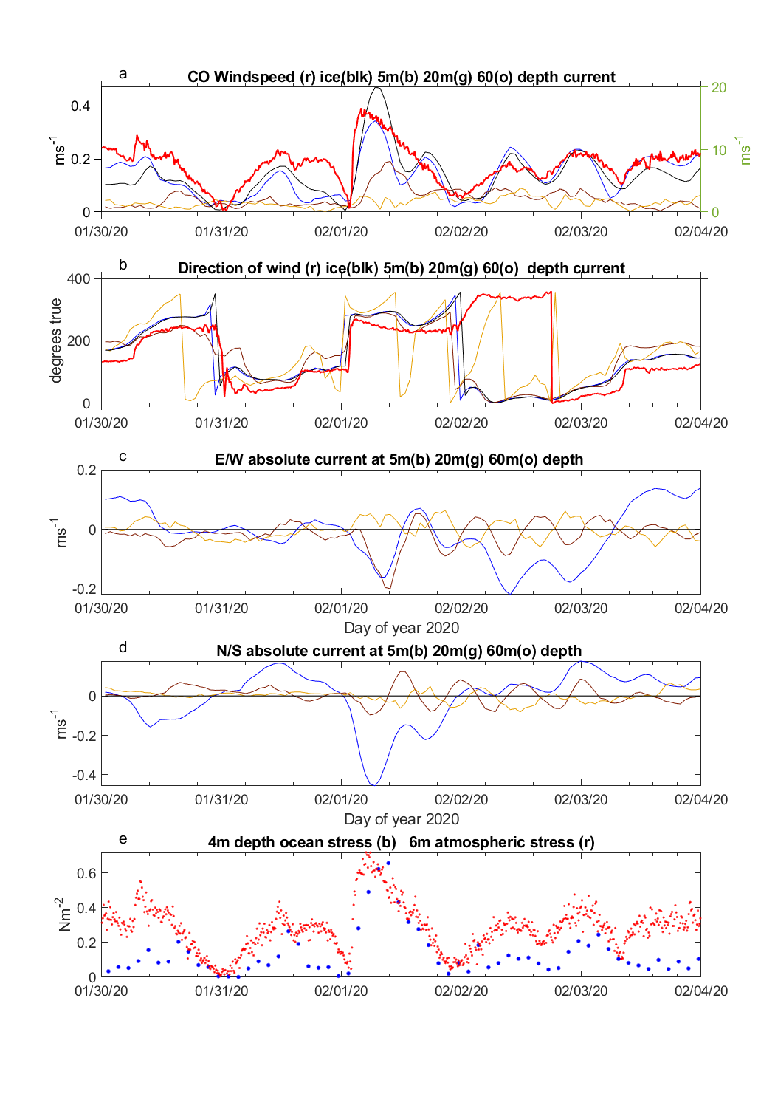

**Figure 11**. Timeseries of windspeed (red), ice speed (black), 5 m (blue) 20 m (green) and 60 m (orange) depth absolute current magnitude. B) Corresponding current directions in degrees true. C) Timeseries of 5 m (blue), 20 m (green) and 60 m (orange) north-south current components. d) east-west current components e) 4 m depth ocean kinematic stress from the CO site Autonomous Ocean Flux Buoy (blue dots) and atmospheric stress (red dots) for this study period.

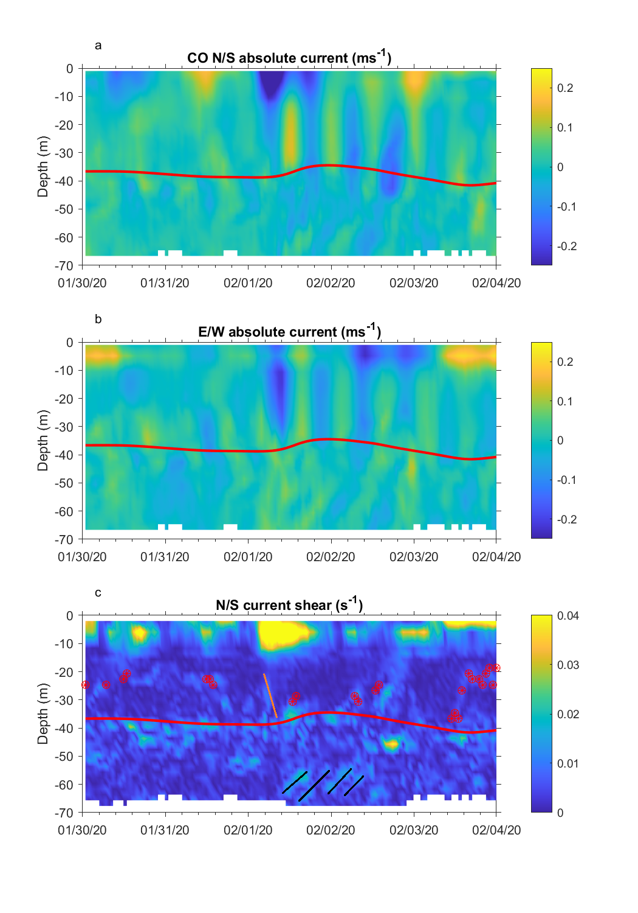

**Figure 12**. North-south current profile timeseries from the L1 site Autonomous Ocean Flux Buoy acoustic Doppler profiler. b) Corresponding East-West current component profiles. c) North/South current shear profiles with a clipped color scale to emphasize shear layers within the ocean mixed layer and upper part of the salinity-stratified pycnocline. Near surface shear reaches 0.07 s-1 during the 1 February wind event. The red timeseries represents an estimate of the depth of the top of the halocline. The sloping orange line highlights the rapid penetration of mixing in response to this wind event. The four black sloping lines identify shear associated with inertial internal waves within the strongly stratified pyncocline forced by the strong inertial motions within the ocean mixed layer.

The highest vertical shear levels of the north/south current component (Figure 12c) are seen in the upper 15 m during the strong 1 February wind event. However, active mixing extends down through the mixed layer to the halocline as seen clearly in the E/W current profile (Figure 12b) and the elimination of shear at the weak stratification interface between 20 m depth and the halocline (marked by the orange line in Figure 12 c). An example of reduced mixing depth by a mesoscale feature at the base of the mixed layer is seen starting at 12:00 UTC on 1 February despite the continued strong surface forcing. Another weak stratification feature extends up from the pycnocline as winds reduce to 3 ms-1 at 00:00 UTC on 2 February. The interplay between surface mixing and these frequent mesoscale features with a wide range of density anomaly strength observed during the MOSAiC drift complicates a 1D view of wind-forced turbulent momentum transfer into the ocean (**Shaw et al and Stanton et al 2023 in prep**).

Strong inertial-period motions in the ocean mixed layer are capable of generating internal inertial-period waves within the pycnocline after the mixing layer inertial currents contact the salinity-stratified pycnocline. In the current component profiles (Figs. 13a and 13b) this can be seen as slanted bands of enhanced current with inertial periods starting around 45 m depth after the 1 February wind event. These regions of enhanced shear are also shown as black slanting lines in Figure 12c. These inertial waves are an important source of shear that can induce mixing in the otherwise very quiescent and non-diffusive Arctic pycnocline.

6 CAFS model results

Simulations with the CAFS model suggest that the spatial distribution of the air-ice-ocean interaction processes may be linked with the atmospheric features associated with the cyclone, and hence are coherent features that follow the atmospheric cyclone. Figure 13 shows the low-level winds and atmospheric divergence, the coupled ice motions and divergence, and the coupled upper-ocean currents and divergence at three times following the modeled cyclone. For the lower atmosphere (Figure 13, top row), the wind and divergence patterns are what is expected for an Arctic cyclone. The low-level wind circulates cyclonically around the low center, with enhanced winds at preferred regions associated with the LLJ (e.g., near the warm front/warm sector, and in the post-cold frontal areas in an annulus around the low) with sharper wind direction changes near the surface fronts. Low-level convergence (negative divergence) is typically strongest with both the warm and cold-frontal regions, while low-level atmospheric divergence is primarily associated with the post-cold-frontal region where atmospheric descent is expected.

The atmospheric wind forcing of the ice motion (Figure 13, middle row) produces an ice circulation center that is offset from the atmospheric circulation center (the atmospheric low). Furthermore, the wind forcing produces ice convergence in the area near the warm front and into the warm sector of the atmospheric cyclone, and significant ice divergence just ahead of and behind the atmospheric cold front. This general pattern of ice divergence trailing the atmospheric low and ice convergence in the warm-frontal region ahead of the propagating cyclone is similar to that produced by the idealized cyclone of Haapala, (2005), though they did not analyze the atmospheric structure of their cyclone. In the CAFS simulation of our event, the ice motion, in turn, forces ocean mixed-layer currents that have a more complicated “S-shaped” spatial structure (Figure 18, bottom row) without a clear circulation center. Of perhaps more importance, the ice motion produces a pronounced upper-ocean divergence pattern during the passage of the atmospheric cyclone. This ocean divergence dominates in the atmospheric warm sector, and near and behind the cold front. There is even ocean divergence on the cold side of the atmospheric cyclone. One may speculate that this cyclone may produce ocean upwelling in response to the mixed-layer divergence, though observations do not exist to verify this.

These characteristics in the CAFS model are clearly consistent with the observations seen in this study. However, more detailed comparisons between the CAFS coupled model output and the observations show that the air-ice coupling appears “muted”, with, for instance, smaller drift ratios and turning angles than for observations described in section 4a of this study. This different response to the coupling in CAFS may alter the quantitative details of the spatial coupling effects of the passage of this cyclone described in Figure 13. However, the qualitative patterns appear consistent with the observations. Detailed comparisons between the observations of this case and coupled model output, including those from CAFS, will be described in a companion paper (**Solomon et al 2024**).

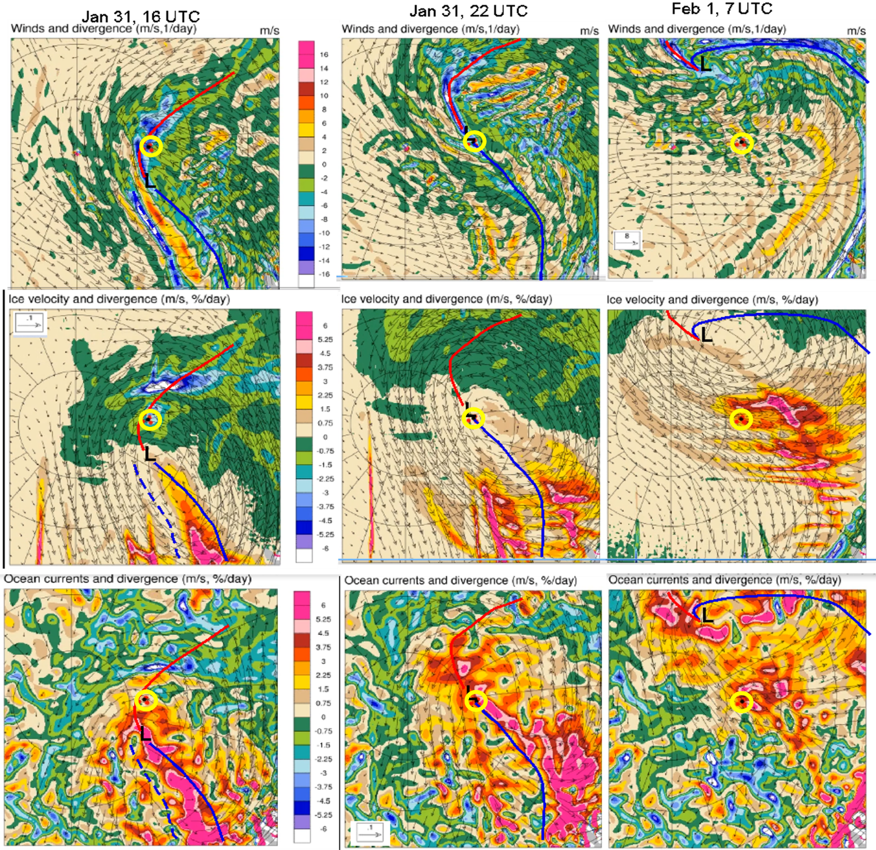

**Figure 13**. CAFS model output of top row: 10-m atmospheric winds (vectors) and divergence (color), middle row: ice velocity (vectors) and ice divergence (color), and bottom row: ocean mixed-layer current (vectors) and divergence (color) at column 1: 16 UTC Jan 31, column 2: 22 UTC Jan 31, and column 3: 7 UTC Feb 1. In each panel, the atmospheric warm (red) and cold (blue) fronts are marked by heavy lines. The yellow circle shows the location of the MOSAiC DN at each time.

7 Discussion and conclusions

Lindsay (2002) analyzed the deformation of the sea ice around the SHEBA camp at daily timescales and approximately 100 km length scales, and identified a pattern of divergence followed by convergence associated with the passage of a strong winter cyclone. This pattern occurred over a period of multiple days, compared to the brief event observed here. They describe challenges associated with measuring deformation of semi-rigid plates from sparse velocity measurements (see also Thorndike, 1986). In the case of a diagonal crack crossing a square polygon, shear along the crack will result in a measurement of opening or closing. Considering the deformation of the L-site triangle, the anamolous convergence shown in Figure 9a is likely an artifact of the triangle orientation relative to a shear zone. The presence of this shear zone is clearly visibile in the velocity anomaly map of Figure 9e. Higher confidence can be placed in the estimate of deformation from the DN Full array due to the larger number of buoys used.

Turbulent ocean fluxes during SHEBA (McPhee, 2002)

During the N-ICE 2015 drift, the largest observed mean upper ocean current speeds tended to coincide with storm events (Meyer, Sundfjord, et al., 2017) with the strongest ocean mixing response occurring when the sea ice drift speeds exceed 40 cm/s (Meyer, Fer, et al., 2017).While we are not considering the full MOSAiC drift here, the maximum sea ice drift speeds in this case also exceeded 40 cm/s, and the peak ocean current speed was associated with the drift speed maximum, with a lag in the peak timing with depth consistent with the downward flux of momentum.

Sea ice deformation - Pattern of vorticity from Haller et al, measurements from Itkin 2017…

Inertial oscillations in sea ice and in the upper ocean are frequently observed following cyclones. The oscillations in the drift speed and current speed appear at first glance to be inertial, however we note too that the wind speed increases and decreases at a similar ~12 hr frequency. (From earlier draft: “It has also been noted that the late July-early August SHEBA cyclones initiated strong inertial ice motions (Persson 2013; Persson and Solomon 2014).”)

Changes in sea ice concentration due to cyclones have been noted by multiple authors. In their analysis of composite cyclone structure, Clancy et al. (2022) examined the change in sea ice concentration over a ten-day period centered at the time of cyclone passage using observations and a model and found a roughly hemispheric response, with increased sea ice concentration to the left of the storm track and decreased sea ice concentration to the right of the storm track with magnitudes of up to 3%. Similar magnitudes of change were found for the 24 hr period following cyclone passage by Kriegsmann & Brümmer (2014), however, their composites had random orientation so only a weak, radial dependence is visible. We examined daily average sea ice concentration maps derived from microwave brightness temperature; however, the uncertainty in standard gridded products (e.g., the National Snow and Ice Data Center Climate Data Record of Passive Microwave Sea Ice Concentration, Meier et al., 2021) are approximately 5% in midwinter conditions (Andersen et al., 2007), hence larger than the expected signal, and can be biased by high atmospheric water content. Furthermore, it is challenging to interpret daily average sea ice concentration maps, which contain data from varying times depending on satellite overpass times, in the context of a fast-moving atmospheric pattern; a swath-by-swath approach is possible but is beyond the scope of this study. With the buoy polygons used for sea ice deformation, we can measure the change of area, and interpret that in the context of sea ice concentration change. Over the 10-day period from 26 January 2020 to 5 February 2020, the area of the “DN Full” polygon (Figure) changed from 3.17km2 to 3.21km2, a change of just over 1%. Rapid area increase (i.e., positive divergence) occurred on 1 February due to the passage of the cold sector low-level jet, such that the area of the polygon increased by 3.5% in a 9-hour period. Given that the surface air temperature was -10 °C or below during this period, any leads would have quickly begun freezing over; the net increase of area over the 10-day period is an indicator of thermodynamic ice growth.

8 Conclusions

We presented a detailed description of an observed strong mid-winter, central Arctic cyclone. The position of the MOSAiC DN relative to the storm track provides a rare view of the spatial and temporal variation of coupled air-ice-ocean processes during an evolving cyclone.

(All figures and tables should be cited in order. For initial submission, please embed figures, tables, and their captions within the main text near where they are cited. At revision, figures should be uploaded separately, as we need separate files for production. Tables and all captions should be moved to the end of the file.)

References should use a name-date format, not numbers. Enclose citations in parentheses with authors in upright text (non italics) as in: (Smith et al*.,* 2009) or Smith et al. (2009). More information on in-text citations can be found in our [Brief Style Guide](https://publications.agu.org/brief-guide-agu-style-grammar/#reference),“Reference Formatting.”

**Acknowledgments**

This work was funded by the US Department of Energy (DoE), under grant 13016524. Tim Stanton’s participation was funded through the National Science Foundation (NSF) grant ??. Jari Haapala was funded by ??. Atmospheric measurements were supported by NSF (Ola/Shupe grant numbers) and the DoE Atmospheric Radiation Measurement Program (Ola/Shupe grant number). The deployment of GPS ice drifters and coordination within the MOSAiC DN was funded by NSF 1722729.The authors do not percieve any conflicts of interest. We thank the MOSAiC Distributed Network Team for additional GPS ice drift data and coordination of the L sites and buoy deployments. The MOSAiC atmosphere team provided support in data collection during the MOSAiC field campaign, running instruments in the CO and maintaining the ASFS at L sites. The MOSAiC sea ice and snow team on MOSAiC Leg 2, in particular Polona Itkin, supported the ice RADAR data collection. The atmospheric, oceanographic and ice drift data used in this paper are archived at the Arctic Data Center (link to data citations in the reference list). Ice RADAR data is archived in the Alfred Wegner institute PANGAEA archive (link to url or doi in reference list).

* Funding information related to the work for all authors should be entered in the form in GEMS as part of your submission. This form in GEMS uses the official Fundref list, which provides a link after publication that is available to funders. Any other funding information not listed in the GEMS form should be included in the acknowledgments and/or cover letter.

**Open Research**

AGU requires an Availability Statement for the underlying data and code needed to understand, evaluate, and build upon the reported research at the time of peer review and publication. Additionally, authors should include an Availability Statement for the software and other research products that have a significant impact on the research. Details and templates are in the [Availability Statement](https://www.agu.org/Publish-with-AGU/Publish/Author-Resources/Data-and-Software-for-Authors#availability) section of the Data & Software for Authors Guidance. For physical samples, use the IGSN persistent identifier, see the [International Geo Sample Numbers](https://www.agu.org/Publish-with-AGU/Publish/Author-Resources/Data-and-Software-for-Authors#IGSN) section.

References

References in supporting information must also be included in the reference list of the main paper, or in a designated section in the main paper so that they will be discovered, linked, and indexed. A separate list in the supporting information is not necessary. References are not included in word counts for excess length fees.

In the References section, cite the data/software described in the Availability Statement (this includes primary and processed data used for your research). For details on data/software citation as well as examples, see the [Data & Software Citation](https://www.agu.org/Publish-with-AGU/Publish/Author-Resources/Data-and-Software-for-Authors#citation) section of the Data & Software for Authors guidance.

All references must be available to readers at the time of publication; there should be no “unpublished”, in preparation, under review, or “in press” references. Please write the respective journal with any questions.

Andersen, S., Tonboe, R., Kaleschke, L., Heygster, G., & Pedersen, L. T. (2007). Intercomparison of passive microwave sea ice concentration retrievals over the high‐concentration Arctic sea ice. *Journal of Geophysical Research: Oceans*, *112*(C8), 2006JC003543. https://doi.org/10.1029/2006JC003543

Aue, L., Vihma, T., Uotila, P., & Rinke, A. (2022). New Insights Into Cyclone Impacts on Sea Ice in the Atlantic Sector of the Arctic Ocean in Winter. *Geophysical Research Letters*, *49*(22). https://doi.org/10.1029/2022GL100051

Bliss, A. C., Hutchings, J. K., & Watkins, D. M. (2023a). Sea ice drift tracks from autonomous buoys in the MOSAiC Distributed Network. *Scientific Data*, *10*(403), 1–10. https://doi.org/10.1038/s41597-023-02311-y

Bliss, A. C., Hutchings, J. K., & Watkins, D. M. (2023b). Sea ice drift tracks from autonomous buoys in the MOSAiC Distributed Network. *Scientific Data*, *10*(403), 1–10. https://doi.org/10.1038/s41597-023-02311-y

Brenner, S., Thomson, J., Rainville, L., Crews, L., & Lee, C. M. (2023). Wind-Driven Motions of the Ocean Surface Mixed Layer in the Western Arctic. *Journal of Physical Oceanography*, *53*(7), 1787–1804. https://doi.org/10.1175/JPO-D-22-0112.1

Brümmer, B. (2003). A Fram Strait cyclone: Properties and impact on ice drift as measured by aircraft and buoys. *Journal of Geophysical Research*, *108*(D7), 4217. https://doi.org/10.1029/2002JD002638

Brümmer, B., & Hoeber, H. (1999). A mesoscale cyclone over the Fram Strait and its effects on sea ice. *Journal of Geophysical Research: Atmospheres*, *104*(D16), 19085–19098. https://doi.org/10.1029/1999JD900259

Brümmer, B., Schröder, D., Müller, G., Spreen, G., Jahnke-Bornemann, A., & Launiainen, J. (2008). Impact of a Fram Strait cyclone on ice edge, drift, divergence, and concentration: Possibilities and limits of an observational analysis. *Journal of Geophysical Research: Oceans*, *113*(12), 1–15. https://doi.org/10.1029/2007JC004149

Cassano, J. J., DuVivier, A., Roberts, A., Hughes, M., Seefeldt, M., Brunke, M., Craig, A., Fisel, B., Gutowski, W., Hamman, J., Higgins, M., Maslowski, W., Nijssen, B., Osinski, R., & Zeng, X. (2017). Development of the Regional Arctic System Model (RASM): Near-surface atmospheric climate sensitivity. *Journal of Climate*, *30*(15), 5729–5753. https://doi.org/10.1175/JCLI-D-15-0775.1

Clancy, R., Bitz, C. M., Blanchard-Wrigglesworth, E., McGraw, M. C., & Cavallo, S. M. (2022). A cyclone-centered perspective on the drivers of asymmetric patterns in the atmosphere and sea ice during Arctic cyclones. *Journal of Climate*, 1–47. https://doi.org/10.1175/JCLI-D-21-0093.1

Colony, R., & Thorndike, A. S. (1984). An estimate of the mean field of Arctic sea ice motion. *Journal of Geophysical Research*, *89*(C6), 10,623-10,629. https://doi.org/10.1029/JC089iC06p10623

Cox, C. J., Gallagher, M. R., Shupe, M. D., Persson, P. O. G., Solomon, A., Fairall, C. W., Ayers, T., Blomquist, B., Brooks, I. M., Costa, D., Grachev, A., Gottas, D., Hutchings, J. K., Kutchenreiter, M., Leach, J., Morris, S. M., Morris, V., Osborn, J., Pezoa, S., … Uttal, T. (2023). Continuous observations of the surface energy budget and meteorology over the Arctic sea ice during MOSAiC. *Scientific Data*, *10*(1), 519. https://doi.org/10.1038/s41597-023-02415-5

Deser, C., Tomas, R. A., & Sun, L. (2015). The role of ocean-atmosphere coupling in the zonal-mean atmospheric response to Arctic sea ice loss. *Journal of Climate*, *28*(6), 2168–2186. https://doi.org/10.1175/JCLI-D-14-00325.1

Dierer, S., Schlünzen, K. H., Birnbaum, G., Brümmer, B., & Müller, G. (2005). Atmosphere–Sea Ice Interactions during a Cyclone Passage Investigated by Using Model Simulations and Measurements. *Monthly Weather Review*, *133*(12), 3678–3692. https://doi.org/10.1175/MWR3076.1

Etling, D., & Brown, R. A. (1993). Roll vortices in the planetary boundary layer: A review. *Boundary-Layer Meteorology*, *65*(3), 215–248. https://doi.org/10.1007/BF00705527

Fearon, M. G., Doyle, J. D., Ryglicki, D. R., Finocchio, P. M., & Sprenger, M. (2021). The Role of Cyclones in Moisture Transport into the Arctic. *Geophysical Research Letters*, *48*(4), e2020GL090353. https://doi.org/10.1029/2020GL090353

Fer, I., Baumann, T. M., Koenig, Z., Muilwijk, M., & Tippenhauer, S. (2022). Upper‐Ocean Turbulence Structure and Ocean‐Ice Drag Coefficient Estimates Using an Ascending Microstructure Profiler During the MOSAiC Drift. *Journal of Geophysical Research: Oceans*, *127*(9). https://doi.org/10.1029/2022JC018751

Gallaher, S. G., Stanton, T. P., Shaw, W. J., Cole, S. T., Toole, J. M., Wilkinson, J. P., Maksym, T., & Hwang, B. (2016). Evolution of a Canada Basin ice‐ocean boundary layer and mixed layer across a developing thermodynamically forced marginal ice zone. *Journal of Geophysical Research: Oceans*, *121*(8), 6223–6250. https://doi.org/10.1002/2016JC011778

Gimbert, F., Marsan, D., Weiss, J., Jourdain, N. C., & Barnier, B. (2012). Sea ice inertial oscillations in the Arctic Basin. *Cryosphere*, *6*(5), 1187–1201. https://doi.org/10.5194/tc-6-1187-2012

Graham, R. M., Cohen, L., Ritzhaupt, N., Segger, B., Graversen, R. G., Rinke, A., Walden, V. P., Granskog, M. A., & Hudson, S. R. (2019). Evaluation of six atmospheric reanalyses over Arctic sea ice from winter to early summer. *Journal of Climate*, *32*(14), 4121–4143. https://doi.org/10.1175/JCLI-D-18-0643.1

Graham, R. M., Hudson, S. R., & Maturilli, M. (2019). Improved performance of ERA5 in Arctic gateway relative to four global atmospheric reanalyses. *Geophysical Research Letters*, *46*(11), 6138–6147. https://doi.org/10.1029/2019GL082781

Haapala, J. (2005). A numerical study of open water formation in sea ice. *Journal of Geophysical Research*, *110*(C9), C09011. https://doi.org/10.1029/2003JC002200

Haller, M., Brümmer, B., & Müller, G. (2014). Atmosphere–ice forcing in the transpolar drift stream: Results from the DAMOCLES ice-buoy campaigns 2007–2009. *The Cryosphere*, *8*(1), 275–288. https://doi.org/10.5194/tc-8-275-2014

Hersbach, H., Bell, B., Berrisford, P., Biavati, G., Horányi, A., Muñoz Sabater, J., Nicolas, J., Radu, C., Rozum, I., Schepers, D., Simmons, A., Soci, C., Dee, D., & Thépaut, J. (2023a). *ERA5 hourly data on pressure levels from 1940 to present.* Copernicus Climate Change Service (C3S) Climate Data Store (CDS). https://doi.org/10.24381/cds.bd0915c6

Hersbach, H., Bell, B., Berrisford, P., Biavati, G., Horányi, A., Muñoz Sabater, J., Nicolas, J., Radu, C., Rozum, I., Schepers, D., Simmons, A., Soci, C., Dee, D., & Thépaut, J. (2023b). *ERA5 hourly data on single levels from 1940 to present.* Copernicus Climate Change Service (C3S) Climate Data Store (CDS). https://doi.org/10.24381/cds.adbb2d47

Hersbach, H., Bell, B., Berrisford, P., Hirahara, S., Horányi, A., Nicolas, J., Peubey, C., Radu, R., Bonavita, M., Dee, D., Dragani, R., Flemming, J., Forbes, R., Geer, A., Hogan, R. J., Janisková, H. M., Keeley, S., Laloyaux, P., Cristina, P. L., & Thépaut, J. (2020). The ERA5 global reanalysis. *Quarterly Journal of the Royal Meteorological Society*, *June*, 1999–2049. https://doi.org/10.1002/qj.3803

Hibler, W. D. (1979). A Dynamic Thermodynamic Sea Ice Model. *Journal of Physical Oceanography*, *9*(4), 815–846. https://doi.org/10.1175/1520-0485(1979)009<0815:ADTSIM>2.0.CO;2

Hunke, E. C., Lipscomb, W. H., Turner, A. K., Jeffery, N., & Elliott, S. (2015). *CICE : the Los Alamos Sea Ice Model Documentation and Software User’s Manual* [Computer software].

Hunkins, K. (1967). Inertial oscillations of Fletcher’s Ice Island (T-3). *Journal of Geophysical Research*, *72*(4), 1165–1174. https://doi.org/10.1029/JZ072i004p01165

Hutchings, J. K., Roberts, A., Geiger, C. A., & Richter-Menge, J. (2011). Spatial and temporal characterization of sea-ice deformation. *Annals of Glaciology*, *52*(57 PART 2), 360–368. https://doi.org/10.3189/172756411795931769

Hutchings, J. K., Roberts, A., Geiger, C. A., & Richter-Menge, J. (2018). Corrigendum: Spatial and temporal characterisation of sea-ice deformation. *Journal of Glaciology*, *64*(244), 343–346. https://doi.org/10.1017/jog.2018.11

Itkin, P., Spreen, G., Cheng, B., Doble, M., Girard-Ardhuin, F., Haapala, J., Hughes, N., Kaleschke, L., Nicolaus, M., & Wilkinson, J. (2017). Thin ice and storms: Sea ice deformation from buoy arrays deployed during N-ICE2015. *Journal of Geophysical Research: Oceans*, *122*(6), 4661–4674. https://doi.org/10.1002/2016JC012403

Jordan, R. E., Andreas, E. L., & Makshtas, A. P. (1999). Heat budget of snow-covered sea ice at North Pole 4. *Journal of Geophysical Research: Oceans*, *104*(C4), 7785–7806. https://doi.org/10.1029/1999JC900011

Kaimal, J. C., & Finnigan, J. J. (1994). *Atmospheric boundary layer flows: Their structure and measurement*. Oxford University Press. https://doi.org/10.1093/oso/9780195062397.001.0001

Kauffman, B. G., & Large, W. G. (2002). *The CCSM coupler, version 5.0.1. Technical Note*. 46 pages.

Kriegsmann, A., & Brümmer, B. (2014). Cyclone impact on sea ice in the central Arctic Ocean: A statistical study. *Cryosphere*, *8*(1), 303–317. https://doi.org/10.5194/tc-8-303-2014

Krumpen, T., von Albedyll, L., Goessling, H. F., Hendricks, S., Juhls, B., Spreen, G., Willmes, S., Belter, H. J., Dethloff, K., Haas, C., Kaleschke, L., Katlein, C., Tian-Kunze, X., Ricker, R., Rostosky, P., Rückert, J., Singha, S., & Sokolova, J. (2021). MOSAiC drift expedition from October 2019 to July 2020: Sea ice conditions from space and comparison with previous years. *The Cryosphere*, *15*(8), 3897–3920. https://doi.org/10.5194/tc-15-3897-2021

Lawrence, D. M., Fisher, R. A., Koven, C. D., Oleson, K. W., Swenson, S. C., Bonan, G., Collier, N., Ghimire, B., Van Kampenhout, L., Kennedy, D., Kluzek, E., Lawrence, P. J., Li, F., Li, H., Lombardozzi, D., Riley, W. J., Sacks, W. J., Shi, M., Vertenstein, M., … Zeng, X. (2019). The Community Land Model Version 5: Description of New Features, Benchmarking, and Impact of Forcing Uncertainty. *Journal of Advances in Modeling Earth Systems*, *11*(12), 4245–4287. https://doi.org/10.1029/2018MS001583

LeMone, M. A. (1973). The Structure and Dynamics of Horizontal Roll Vortices in the Planetary Boundary Layer. *Journal of the Atmospheric Sciences*, *30*, 1077–1091. https://doi.org/10.1175/1520-0469(1973)030<1077:TSADOH>2.0.CO;2

Leppäranta, M. (2007). *The drift of sea ice*. Springer Berlin Heidelberg. https://books.google.com/books?id=MMIXaOl1jxwC

Lindsay, R. W. (2002). Ice deformation near SHEBA. *Journal of Geophysical Research*, *107*(C10), 8042. https://doi.org/10.1029/2000JC000445

López-García, V., Neely, R. R., Dahlke, S., & Brooks, I. M. (2022). Low-level jets over the Arctic Ocean during MOSAiC. *Elementa: Science of the Anthropocene*, *10*(1), 00063. https://doi.org/10.1525/elementa.2022.00063

Lüpkes, C., & Gryanik, V. M. (2015). A stability-dependent parametrization of transfer coefficients formomentum and heat over polar sea ice to be used in climate models. *Journal of Geophysical Research*, *120*(2), 552–581. https://doi.org/10.1002/2014JD022418

Lüpkes, C., Gryanik, V. M., Witha, B., Gryschka, M., Rassch, S., & Gollnik, T. (2008). Modeling convection over arctic leads with LES and a non-eddy-resolving microscale model. *Journal of Geophysical Research: Oceans*, *113*(9), 1–17. https://doi.org/10.1029/2007JC004099

Martini, K. I., Simmons, H. L., Stoudt, C. A., & Hutchings, J. K. (2014). Near-inertial internal waves and sea ice in the Beaufort Sea. *Journal of Physical Oceanography*, *44*(8), 2212–2234. https://doi.org/10.1175/JPO-D-13-0160.1

Maslowski, W., Clement Kinney, J., Higgins, M., & Roberts, A. (2012). The Future of Arctic Sea Ice. *Annual Review of Earth and Planetary Sciences*, *40*(1), 625–654. https://doi.org/10.1146/annurev-earth-042711-105345

McNutt, S. L., & Overland, J. E. (2003). Spatial hierarchy in Arctic sea ice dynamics. *Tellus A: Dynamic Meteorology and Oceanography*, *55*(2), 181–191. https://doi.org/10.3402/tellusa.v55i2.12088

McPhee, M. G. (2002). Turbulent stress at the ice/ocean interface and bottom surface hydraulic roughness during the SHEBA drift. *Journal of Geophysical Research*, *107*(C10), 8037. https://doi.org/10.1029/2000JC000633

McPhee, M. G. (2008). *Air-Ice-Ocean Interaction: Turbulent Ocean Boundary Layer Exchange Processes* (1st ed.). Springer. https://doi.org/10.1007/978-0-387-78335-2

McPhee, M. G., & Kantha, L. H. (1989). Generation of internal waves by sea ice. *Journal of Geophysical Research*, *94*(C3), 3287. https://doi.org/10.1029/JC094iC03p03287

Meier, W. N., Fetterer, F., Windnagel, A. K., & Stewart, S. (2021). *NOAA / NSIDC Climate Data Record of Passive Microwave Sea Ice Concentration, Version 4*. National Snow and Ice Data Center. https://doi.org/10.7265/efmz-2t65

Meyer, A., Fer, I., Sundfjord, A., & Peterson, A. K. (2017). Mixing rates and vertical heat fluxes north of Svalbard from Arctic winter to spring. *Journal of Geophysical Research: Oceans*, *122*(6), 4569–4586. https://doi.org/10.1002/2016JC012441

Meyer, A., Sundfjord, A., Fer, I., Provost, C., Villacieros Robineau, N., Koenig, Z., Onarheim, I. H., Smedsrud, L. H., Duarte, P., Dodd, P. A., Graham, R. M., Schmidtko, S., & Kauko, H. M. (2017). Winter to summer oceanographic observations in the Arctic Ocean north of Svalbard. *Journal of Geophysical Research: Oceans*, *122*(8), 6218–6237. https://doi.org/10.1002/2016JC012391

Nansen, F. (1902). *The Norwegian North polar expedition, 1893-1896: Scientific Results*. London ; New York : Longmans, Green and Co. ; Christiania : J. Dybwad, 1900-1906.

Nicolaus, M., Perovich, D. K., Spreen, G., Granskog, M. A., von Albedyll, L., Angelopoulos, M., Anhaus, P., Arndt, S., Belter, H. J., Bessonov, V., Birnbaum, G., Brauchle, J., Calmer, R., Cardellach, E., Cheng, B., Clemens-Sewall, D., Dadic, R., Damm, E., de Boer, G., … Wendisch, M. (2022). Overview of the MOSAiC expedition: Snow and sea ice. *Elementa: Science of the Anthropocene*, *10*(1). https://doi.org/10.1525/elementa.2021.000046

Oikkonen, A., Haapala, J., Lensu, M., Karvonen, J., & Itkin, P. (2017). Small‐scale sea ice deformation during N‐ICE2015: From compact pack ice to marginal ice zone. *Journal of Geophysical Research*, *122*, 5105–5120.

Overland, J. E. (1985). Atmospheric boundary layer structure and drag coefficients over sea ice. *Journal of Geophysical Research: Oceans*, *90*(C5), 9029–9049. https://doi.org/10.1029/JC090iC05p09029

Overland, J. E., & Pease, C. H. (1982). Cyclone climatology of the Bering Sea and its relation to sea ice extent. *Monthly Weather Review*, *110*, 5–13.

Peng, S., Yang, Q., Shupe, M. D., Xi, X., Han, B., Chen, D., Dahlke, S., & Liu, C. (2023). The characteristics of atmospheric boundary layer height over the Arctic Ocean during MOSAiC. *Atmospheric Chemistry and Physics*, *23*(15), 8683–8703. https://doi.org/10.5194/acp-23-8683-2023

Persson, P. O. G. (2012). Onset and end of the summer melt season over sea ice: Thermal structure and surface energy perspective from SHEBA. *Climate Dynamics*, *39*, 1349–1371. https://doi.org/10.1007/s00382-011-1196-9

Persson, P. O. G., Shupe, M. D., Perovich, D., & Solomon, A. (2017). Linking atmospheric synoptic transport, cloud phase, surface energy fluxes, and sea-ice growth: Observations of midwinter SHEBA conditions. *Climate Dynamics*, *49*(4), 1341–1364. https://doi.org/10.1007/s00382-016-3383-1

Petty, A. A., Hutchings, J. K., Richter-Menge, J. A., & Tschudi, M. A. (2016). Sea ice circulation around the Beaufort Gyre: The changing role of wind forcing and the sea ice state. *Journal of Geophysical Research*, 19.

Pinto, J. O., Alam, A., Maslanik, J. A., Curry, J. A., & Stone, R. S. (2003). Surface characteristics and atmospheric footprint of springtime Arctic leads at SHEBA. *Journal of Geophysical Research - Oceans*, *108*(C4), 8051. https://doi.org/10.1029/2000JC000473

Proshutinsky, A. Y., & Johnson, M. A. (1997). Two circulation regimes of the wind-driven Arctic Ocean. *Journal of Geophysical Research: Oceans*, *102*(C6), 12493–12514. https://doi.org/10.1029/97JC00738

Rabe, B., Heuzé, C., Regnery, J., Aksenov, Y., Allerholt, J., Athanase, M., Davies, A., Damm, E., Dethloff, K., Divine, D. V., Doglioni, F., & Craw, L. (2022). Overview of the MOSAiC expedition: Physical oceanography. *Elementa: Science of the Anthropocene*, *10*, 1–31. https://doi.org/10.1525/elementa.2021.00062

Rae, J. G. L., Todd, A. D., Blockley, E. W., & Ridley, J. K. (2017). How much should we believe correlations between Arctic cyclones and sea ice extent? *The Cryosphere*, *11*(6), 3023–3034. https://doi.org/10.5194/tc-11-3023-2017

Rainville, L., & Woodgate, R. A. (2009). Observations of internal wave generation in the seasonally ice-free Arctic. *Geophysical Research Letters*, *36*(23), L23604. https://doi.org/10.1029/2009GL041291

Richter-Menge, J. A., Perovich, D. K., & Pegau, W. S. (2001). Summer ice dynamics during SHEBA and its effect on the ocean heat content. *Annals of Glaciology*, *33*, 201–206. https://doi.org/10.3189/172756401781818176

Rinke, A., Cassano, J. J., Cassano, E. N., Jaiser, R., & Handorf, D. (2021). Meteorological conditions during the MOSAiC expedition. *Elementa: Science of the Anthropocene*, *9*(1), 1–17. https://doi.org/10.1525/elementa.2021.00023

Roberts, A., Craig, A., Maslowski, W., Osinski, R., DuVIVIER, A., Hughes, M., Nijssen, B., Cassano, J., & Brunke, M. (2015). Simulating transient ice–ocean Ekman transport in the Regional Arctic System Model and Community Earth System Model. *Annals of Glaciology*, *56*(69), 211–228. https://doi.org/10.3189/2015AoG69A760

Schweiger, A. J., & Zhang, J. (2015). Accuracy of short‐term sea ice drift forecasts using a coupled ice‐ocean model. *Journal of Geophysical Research*, 15.

Shaw, W. J., Stanton, T. P., McPhee, M. G., Morison, J. H., & Martinson, D. G. (2009). Role of the upper ocean in the energy budget of Arctic sea ice during SHEBA. *Journal of Geophysical Research*, *114*(C6), C06012. https://doi.org/10.1029/2008JC004991

Shupe, M. D., & Rex, M. (2022). A year in the changing Arctic sea ice. *Oceanography*, *35*(3–4), 224–225.

Shupe, M. D., Rex, M., Blomquist, B., Persson, P. O. G., Schmale, J., Uttal, T., Buck, C., Boyer, M., Hofer, J., Hamilton, J., Posman, K., Powers, H., Pratt, K. A., Preußer, A., Rabe, B., & Rinke, A. (2022). Overview of the MOSAiC expedition-Atmosphere. *Elementa: Science of the Anthropocene*, *10*(1), 1–54. https://doi.org/10.1525/elementa.2021.00060

Shupe, M. D., Rex, M., Dethloff, K., Damm, E., Fong, A. A., Gradinger, R., Heuzé, C., Loose, B., Makarov, A., Maslowski, W., Nicolaus, M., Perovich, D., Rabe, B., Rinke, A., Sokolov, V., & Sommerfeld, A. (2020). *Arctic Report Card 2020: The MOSAiC Expedition: A Year Drifting with the Arctic Sea Ice*. https://doi.org/10.25923/9G3V-XH92

Skamarock, W. C., & Klemp, J. B. (2008). A time-split nonhydrostatic atmospheric model for weather research and forecasting applications. *Journal of Computational Physics*, *227*(7), 3465–3485. https://doi.org/10.1016/j.jcp.2007.01.037

Stanton, T. P., Shaw, W. J., & Hutchings, J. K. (2012). Observational study of relationships between incoming radiation, open water fraction, and ocean-to-ice heat flux in the Transpolar Drift: 2002-2010: OCEAN/ICE FLUXES IN THE ARCTIC. *Journal of Geophysical Research: Oceans*, *117*(C7), n/a-n/a. https://doi.org/10.1029/2011JC007871

Taylor, P. C., Hegyi, B. M., Boeke, R. C., & Boisvert, L. N. (2018). On the increasing importance of air-sea exchanges in a thawing Arctic: A review. *Atmosphere*, *9*(2), 1–39. https://doi.org/10.3390/atmos9020041

Thorndike, A. S. (1986). Diffusion of sea ice. *Journal of Geophysical Research*, *91*(C6), 7691. https://doi.org/10.1029/JC091iC06p07691

Toole, J. M., Timmermans, M. ‐L., Perovich, D. K., Krishfield, R. A., Proshutinsky, A., & Richter‐Menge, J. A. (2010). Influences of the ocean surface mixed layer and thermohaline stratification on Arctic Sea ice in the central Canada Basin. *Journal of Geophysical Research: Oceans*, *115*(C10), 2009JC005660. https://doi.org/10.1029/2009JC005660

Uttal, T., Curry, J. A., McPhee, M. G., Perovich, D. K., Moritz, R. E., Maslanik, J. A., Guest, P. S., Stern, H. L., Moore, J. A., Turenne, R., Heiberg, A., Serreze, M. C., Wylie, D. P., Persson, O. G., Paulson, C. A., Halle, C., Marison, J. H., Wheeler, P. A., Makshtas, A., … Grenfeld, T. C. (2002). Surface heat budget of the arctic ocean. *Bulletin of the American Meteorological Society*, *83*(2), 255–275. https://doi.org/10.1175/1520-0477(2002)083<0255:SHBOTA>2.3.CO;2

Vessey, A. F., Hodges, K. I., Shaffrey, L. C., & Day, J. J. (2020). An inter-comparison of Arctic synoptic scale storms between four global reanalysis datasets. *Climate Dynamics*, 2777–2795.

Vessey, A. F., Hodges, K. I., Shaffrey, L. C., & Day, J. J. (2022). The composite development and structure of intense synoptic-scale Arctic cyclones. *Weather and Climate Dynamics*, *3*(3), 1097–1112. https://doi.org/10.5194/wcd-3-1097-2022

von Albedyll, L., Hendricks, S., Grodofzig, R., Krumpen, T., Arndt, S., Belter, H. J., Birnbaum, G., Cheng, B., Hoppmann, M., Hutchings, J., Itkin, P., Lei, R., Nicolaus, M., Ricker, R., Rohde, J., Suhrhoff, M., Timofeeva, A., Watkins, D., Webster, M., & Haas, C. (2022). Thermodynamic and dynamic contributions to seasonal Arctic sea ice thickness distributions from airborne observations. *Elementa: Science of the Anthropocene*, *10*(1), 00074. https://doi.org/10.1525/elementa.2021.00074

Wang, C., Graham, R. M., Wang, K., Gerland, S., & Granskog, M. A. (2019). Comparison of ERA5 and ERA-Interim near-surface air temperature, snowfall and precipitation over Arctic sea ice: Effects on sea ice thermodynamics and evolution. *The Cryosphere*, *13*(6), 1661–1679. https://doi.org/10.5194/tc-13-1661-2019

Watkins, D. M., Bliss, A. C., Hutchings, J. K., & Wilhelmus, M. M. (2023). Evidence of Abrupt Transitions Between Sea Ice Dynamical Regimes in the East Greenland Marginal Ice Zone. *Geophysical Research Letters*, *50*(e2023GL103558), 1–10.

Webster, M. A., Parker, C., Boisvert, L., & Kwok, R. (2019). The role of cyclone activity in snow accumulation on Arctic sea ice. *Nature Communications*, *10*(1), 5285. https://doi.org/10.1038/s41467-019-13299-8

Womack, A., Vichi, M., Alberello, A., & Toffoli, A. (2022). Atmospheric drivers of a winter-to-spring Lagrangian sea-ice drift in the Eastern Antarctic marginal ice zone. *Journal of Glaciology*. https://doi.org/10.1017/jog.2022.14

Yang, J. (2004). Storm-driven mixing and potential impact on the Arctic Ocean. *Journal of Geophysical Research*, *109*(C4), C04008. https://doi.org/10.1029/2001JC001248

Yu, Y., Xiao, W., Zhang, Z., Cheng, X., Hui, F., & Zhao, J. (2021). Evaluation of 2-m Air Temperature and Surface Temperature from ERA5 and ERA-I Using Buoy Observations in the Arctic during 2010–2020. *Remote Sensing*, *13*(14), 2813. https://doi.org/10.3390/rs13142813

Yuan, D., Hao, Z., You, J., Zhang, P., Yin, B., Li, Q., & Xu, Z. (2022). Enhancing Sea Ice Inertial Oscillations in the Arctic Ocean between 1979 and 2019. *Water*, *15*(1), 152. https://doi.org/10.3390/w15010152